INSTITUTION OF GAS ENGINEERS AND MANAGERS IGEM/TSP/24/255

Founded 1863

IGEM/GM/8 PART 5 EDITION 3 Royal Charter 1929

Communication XXXX Patron: His Majesty the King

Meter installations of flow exceeding 6 m³ per hour

Part 5 : Notices and labels

DRAFT FOR COMMENT

- This draft Standard IGEM/GM/8 Part 5 Edition 3 has been prepared by IGEM Secretariat.

- This Draft for comment is presented to Industry for comments which are required by 17th January 2025, and in accordance with the attached Reply Form.

3 This is a draft document and should not be regarded or used as a fully approved and published Standard. It is anticipated that amendments will be made prior to publication.
It should be noted that this draft Standard contains intellectual property belonging to IGEM. Unauthorised copying or use by any unauthorised person or party is not permitted.

4 This is a copyright document of the Institution of Gas Engineers and Managers. Enquiries should be addressed in the first instance to:
Peter Hurst
IGEM
IGEM House
26-28 High Street
Kegworth
Derbyshire, DE74 2DA
Tel: 01509 678158
Email: peter@igem.org.uk

Attached is the Draft for Comment of IGEM/GM/8 Edition 3 – “Meter installations of flow exceeding 6 m³ per hour” Part 5 : Notices and labels and the associated comment form.

We wish to make it as easy as possible for those of you representing industry bodies to issue the draft to your Members. You can either forward this email with attachment complete or forward it without the attachment and invite them to visit our website via https://www.igem.org.uk/technical/technical-services/comment-on-draft-standards.html
where the Draft and Comment Form is posted.

Organisations to which this Draft has been circulated:

Organisation Representative
AMO ERIC FOWLER
BPEC MALLY BUTTERS
BRITISH GAS BRETT JOHNSON
CADENT HILARY BUXTON
CMAP JOHN HEYBURN
DNO COLLAB FORUM HILARY BUXTON
EI MARK SCANLON
ENA JAMES EARL
EUA STEVE SUTTON
EUSKILLS RICHARD HARPER
GSR JONATHAN PALMER
GISG BOB MURRY
HHIC STEVEN SUTTON
HSENI SEAN KEOGH
*Large Business Forum TREVOR SMALLPEICE
LLOYDS REGISTER LES THOMAS
RETAIL ENERGY CODE (REC) ERIC FOWLER
NGN IAIN FOSTER
OFGEM VIC TUFFEN
SGN DOMINIC CUMMINGS
WALES & WEST GRANT ROGERS
YPN HARRIET GUIRY.

IGEM/GM/8 Part 5 Edition 3
Communication xxxx
Meter installations of flow exceeding 6 m³ per hour

Part 5 : Notices and labels

DRAFT FOR COMMENT

IGEM/GM/8 Part 5 Edition 3
Communication xxxx
Meter installations of flow exceeding 6 m³ per hour

Part 5 : Notices and labels
DRAFT FOR COMMENT

Copyright © 2024, IGEM. All rights reserved
Registered charity number 214011

All content in this publication is, unless stated otherwise, the property of IGEM. Copyright laws protect this publication. Reproduction or retransmission in whole or in part, in any manner, without the prior written consent of the copyright holder, is a violation of copyright law.

ISBN 978 1 xxxxx xx xx
Published by the Institution of Gas Engineers and Managers

Previous Publications:
Communication 1710 (2006) – 1st Edition
Communication 1799 (2016) – 2nd Edition

For information on other IGEM Standards please visit our website, www.igem.org.uk

CONTENTS

SECTION PAGE

1 Introduction 1

2 Scope 4

3 Legal and allied considerations 6

    - 3.1 General 6
    - 3.2 Dangerous Substances and Explosive Atmospheres Regulations 6
(DSEAR)
    - 3.3 Gas Safety (Installation and Use) Regulations (GS(I&U)R) 7
    - 3.4 Health and Safety at Work etc. Act (HSWA) 7
    - 3.5 Management of Health and Safety at Work Regulations (MHSWR) 7
    - 3.6 Pressure Systems Safety Regulations (PSSR) 7

4 General 9

5 Composite notices 13

- Notices that are required by legal instrument 17

      - 6.1 Notices to be provided either as individual notices and/or as
part of a composite notice 17
      - 6.1.1 Suspected gas escapes (under GS(I&U)R) 17
      - 6.1.2 Secondary meters (under GS(I&U)R) 17
      - 6.1.3 Line diagrams (under GS(I&U)R or this Standard) 19
    - 6.1.4 ATEX UKCA EX (under DSEAR) 19
    - 6.1.5 Remote ECV (from meter) (under GS(I&U)R) 19
      - 6.2 Notices to be provided as an individual notice 20
      - 6.2.1 Additional emergency control valve(s) (AECV(s))
(GS(I&U)R) 20
      - 6.2.2 ECV 23

7 Notices that are required by this Standard 25

    - 7.1 Notices to be provided as individual notices and/or as
part of a composite notice 25
      - 7.1.1 Non-return valves (NRVs) 25
      - 7.1.2 Gas pressures 25
      - 7.1.3 Notice of MOP downstream of the meter
installation exceeding 75 mbar 28
        - 7.1.4 Protective equipotential bonding 28
    - 7.2 Notices to be provided as an individual notice 30
      - 7.2.1 Meter by-pass valve (MBV) 30
      - 7.2.2 Testing, purging and commissioning 30

8 Optional notices 32

    - 8.2 Gas compressors and gas engines 32
    - 8.3 Valve identification for multiple valve installations 33
    - 8.4 Stream identification 34
    - 8.5 Thermowells 37
    - 8.6 Security seals 38
    - 8.7 Flow straighteners (turbine meters only) 39
    - 8.8 Testing from the meter inlet valve 39

9 Pipework identification and colour coding 41

10 General health and safety notices 42

      - 10.1 No smoking/gas escapes 42
      - 10.2 Personal protective equipment (PPE) 42
      - 10.3 Emergency exits 43
      - 10.4 Lifting 43

11 Data plates 45

- 11.4 Meter removal 46

APPENDIX

1 Glossary, acronyms, abbreviations, symbols, units and subscripts 47

2 References 50

FIGURES

- Positioning of notices (typical arrangement). All individual notices 11

2 Positioning of notices (typical arrangement). Composite notice plus
individual notices 12

3 Typical comprehensive composite notice 14

4 Typical overlay for a composite notice. Twin stream regulator installation 15

5 Typical overlay for composite notice. Single stream regulator installation
with meter by-pass 15

6 Typical overlay for a composite notice. Twin stream regulator installation
with meter by-pass 16

7 Typical overlay for warning of high pressure gas supply 16

8 Typical notice of action to be taken in the event of a suspected gas escape 17

9 Typical notice of secondary meters 18

10 EX label 19

11 Typical labelling of an AECV 21

12 Typical labelling of direction of operation of an AECV lever type valve 23

13 Substitute ECV label 24

14 Typical notice of protection of the network 21

15A Typical notice of gas pressures 26
15B Typical notice of gas pressure settings 27

16 Typical notice of MOP downstream of the meter installation exceeding 75 mbar 28

17 Typical notice for protective equipotential bonding 29

18 Typical notice of a meter by-pass valve (MBV) 30

19 Typical notice after testing, purging and commissioning 31

20 Typical notice at the meter installation of a gas compressor or engine 32

21 Typical notice of a meter inlet valve 34

22 Typical notices for multiple streams for the purpose of continuity of supply 35

23 Typical notices for multiple streams for the purpose of achieving capacity 36

24 Typical notice for a thermowell 37

25 Typical notice for a security seal 38

26 Typical tape used as a notice of a flow straightener 39

27 Guidance for testing from the MIV 40

28 Typical gas marker tape 41

29 Positioning gas marker tape 41

30 Typical “no smoking” and gas escapes notice 42

31 Typical positions of housing notices 43

32 Typical positions of compound notices 44

33 Typical labels for identifying removed metering equipment 46

SECTION 1 : INTRODUCTION

  - This Standard supersedes IGEM/GM/8 Part 5, Communication 1799, which is obsolete.

1.2 This Standard has been drafted by an Institution of Gas Engineers and Managers (IGEM) Panel, appointed by IGEM’s Gas Measurement Committee and subsequently approved, and has been approved by IGEM’s Technical Co-ordinating Committee on behalf of the Council of IGEM.

1.3 IGEM/GM/8 is published in 5 parts:
- Part 1 covering design
- Part 2 covering locations, housings and compounds
- Part 3 covering installation and commissioning
- Part 4 covering operation and maintenance
- Part 5 covering notices and labels.

1.4 This Standard covers notices and labels for gas supply meter installations (see Sub-Section 2.1) of capacity exceeding 6 m³ h⁻¹ and maximum operating pressure (upstream) (MOP_{u}) not exceeding 38 bar.

With the exception of the few installations of MOP_{u} exceeding 38 bar, the majority of industrial and commercial meter installations can be operated and maintained by following IGEM/GM/6 (for MOP_{u} not exceeding 75 mbar only) and/or IGEM/GM/8.

Note: IGEM Standards use pressure breaks as adopted in European standards. However, in the UK, the actual limit of pressure for IGEM/GM/6 designs is 75 mbar. In practice, it is rare for a meter installation to have MOP_{u} lying between 75 mbar and 100 mbar, in the UK.

It is the intention that IGEM/GM/6 be used for the largest proportion of installations that can be covered by “standard designs” for MOP_{u} not exceeding 75 mbar.

For 75 mbar < MOP_{u} ≤ 38 bar or where an installation is not a “standard design” as specified in IGEM/GM/6, IGEM/GM/8 applies (see also Note 4 to Sub-Section 2.1).

For a turbine meter installation of MOP_{u} not exceeding 75 mbar, there are no recognised standard designs i.e. IGEM/GM/6 does not apply. It is recommended that IGEM/GM/8 be used for all such installations.

For any meter installation of MOP_{u} exceeding 38 bar, IGEM/GM/4 applies.

1.5 This Standard applies to new, onshore, gas supply meter installations only. It is not retrospective. However, where work needs to be undertaken on a meter installation, it is recommended that such an installation be brought into line with this Standard. In particular, any unregulated by-pass needs to be removed or a regulator installed in the by-pass.

When re-engineering or replacing legacy meter installations, consideration is to be given to bringing them in line with the standard arrangements within IGEM/G/1. Unless all involved parties are in agreement to continue the legacy arrangement, it is expected that if reasonably practicable such existing systems will be modified to meet the recommended approach.

Irrespective of whether an emergency control valve (ECV) is fitted to the inlet of the meter installation, it is recommended that modification work be undertaken in line with this Standard.

Ownership and responsibility for new installations covered by this Standard has been liberalised from gas transporters (GTs) to Meter Asset Providers (MAPs) who are the title owner of the assets, and Meter Asset Managers (MAMs), responsible for management. The regulation authority, the Office of Gas and Electricity Markets (Ofgem) require that equipment managers and installers are separately accredited for the work they carry out. Accredited MAMs have operational and management responsibly while Accredited Meter Installers (AMI) carry out meter work, installation, modification, repair, maintenance and removal activities, both work to the Retail Energy Code Consolidated Metering Code of Practice (REC CoMCoP).

Licence conditions make gas suppliers responsible for coordinating the provision of metering services and have placed responsibilities on GTs to underpin the overall safety of the gas supply system from the distribution main to the inlet of the consumer’s appliances.

Note: Under these arrangements, a REC MAM does not have to be an AMI, but has an obligation to use an AMI to carry out work on a meter installation or have the work inspected by an AMI within 20 days of the work.

Notwithstanding Sub-Section 1.11, total compliance with IGEM/GM/8 is necessary for installations and modules where the meter installation has to comply with the CoMCoP.

1.6 This Standard does not detail the management processes required for compliance with the Pressure Systems Safety Regulations (PSSR), such guidance is provided by IGEM/GL/5. It is intended that work carried out in accordance with this Standard and IGEM/GL/5 will conform to the requirements of the PSSR.

1.7 Terms such as “maximum operating pressure” (MOP), “maximum incidental pressure” (MIP) and “operating pressure” (OP) are used to reflect gas pressure terminology used in European standards. These terms will arise in all relevant IGEM Standards and, possibly, in other standards. Other terms have been introduced to assist in recognition of design information to be transferred between interested parties.

Note: Appendix 11 of IGEM/GM/8 Part 1 shows an explanation of the terms used by setting out the definitions of the terms, explaining the suffixes, the relationship between the terms, and their significance. It is strongly recommended that Appendix 11 be read immediately.

1.8 This Standard makes use of the terms “must”, “shall” and “should” when prescribing particular procedures. Notwithstanding Sub-Section 1.9:
    - the term “must” identifies a requirement by law in Great Britain (GB) at the time of publication
    - the term “shall” prescribes a procedure which, it is intended, will be complied with in full and without deviation
    - the term “should” prescribes a procedure which, it is intended, will be complied with unless, after prior consideration, deviation is considered to be acceptable.

Such terms may have different meanings when used in Legislation, or Health and Safety Executive (HSE) Approved Code of Practice (ACoPs) or guidance, and reference needs to be made to such statutory legislation or official guidance for information on legal obligations.

1.9 The primary responsibility for compliance with legal duties rests with the employer. The fact that certain employees, for example “responsible engineers”, are allowed to exercise their professional judgement does not allow employers to abrogate their primary responsibilities. Employers are required to:
- have done everything to ensure, so far as it is reasonably practicable, that “responsible engineers” have the skills, training, experience and personal qualities necessary for the proper exercise of professional judgement
- have systems and procedures in place to ensure that the exercise of professional judgement by “responsible engineers” is subject to appropriate monitoring and review
- not require “responsible engineers” to undertake tasks which would necessitate the exercise of professional judgement that is not within their competence. There are to be written procedures defining the extent to which “responsible engineers” can exercise their professional judgement. When “responsible engineers” are asked to undertake tasks which deviate from this, they are to refer the matter for higher review.

1.10 It is now widely accepted that the majority of accidents in industry generally are in some measure attributable to human as well as technical factors in the sense that actions by people initiated or contributed to the accidents, or people might have acted in a more appropriate manner to avert them.

It is therefore necessary to give proper consideration to the management of these human factors and the control of risk. To assist in this, it is recommended that due regard be paid to HSG48.

1.11 Notwithstanding Sub-Section 1.8, this Standard does not attempt to make the use of any method or specification obligatory against the judgement of the responsible engineer. Where new and better techniques are developed and proved, they are to be adopted without waiting for modification to this Standard. Amendments to this Standard will be issued when necessary, and their publication will be announced in the Journal of the Institution and elsewhere, as appropriate.

  - Requests for interpretation of this Standard in relation to matters within their scope, but not precisely covered by the current text, is to be addressed in writing to:
- Technical Services, The Institution of Gas Engineers and Managers, IGEM House, High Street, Kegworth, Derbyshire, DE74 2DA, or
- email to technical@igem.org.uk,
and will be submitted to the relevant Committee for consideration and advice, but in the context that the final responsibility is that of the engineer concerned. If any advice is given by or on behalf of IGEM, this does not relieve the responsible engineer of any of their obligations.

  - This Standard was published in xxxxxx 202x.

SECTION 2 : SCOPE

  - This Standard applies to all new onshore gas supply meter installations (hereafter referred to as “installations”) (and defined in IGEM/G/1) of flow rate (capacity) exceeding 6 m³ h⁻¹ and MOP_{u} not exceeding 38 bar.

The following types of meter are covered:
- diaphragm
- rotary displacement (RD)
- turbine
- ultrasonic (USM)
- thermal mass.

Note 1: For installations of capacity not exceeding 6 m³ h⁻¹, intended to carry Natural Gas (NG), BS 6400-1 or BS 6400-2 apply, as appropriate for MOP_{u}. For non-domestic premises there are additional legal requirements that may have to be met, e.g. Dangerous Substances and Explosive Atmospheres Regulations (DSEAR).

The requirements of this document may be applied to installations of capacity not exceeding 6 m³ h⁻¹ and MOP_{u} exceeding 2 bar.

Note 2: For installations of MOP_{u} exceeding 38 bar, IGE/GM/4 applies and IGEM/TD/13 may be used for the regulation of pressure, however, where the metering pressure is not exceeding 38 bar, this Standard applies to the metering element in accordance with Figures 9 – 27 of IGEM/GM/8 Part 1. Where IGEM/TD/13 is used, the control and fault pressure ranges have to be acceptable to the consumer, it may be necessary to apply tolerances required by IGEM/GM/8 to IGEM/TD/13 control philosophy.

Note 3: Primarily, IGEM/GM/8 has been produced for primary meters and other meters used for billing purposes. However, the principles may be applied for other meters, for example appliance check meters or departmental charging meters, when certain requirements may not apply.

Note 4: IGEM/GM/6 provides requirements for “standard” installations of MOP_{u} not exceeding 100 mbar. For other, “non-standard”, installations of MOP_{u} not exceeding 100 mbar, IGEM/GM/8 applies. See also the note within Sub-Section 1.4.

Note 5: For turbine meters and USMs, in addition to IGEM/GM/8, some of the principles of IGE/GM/4 may apply and further useful information is also included.

Note 6: IGEM/GM/8 does not address the Network pipeline (see IGEM/TD/1, IGEM/TD/3, IGE/TD/4 and IGEM/G/5, as appropriate). IGEM/GM/8 does not address requirements for a pressure regulating installation (PRI) installed in a Network pipeline that is not part of the meter installation, when IGEM/TD/13 applies.

2.2 This Standard is primarily written to cover installations that are wholly downstream of the outlet of the ECV as recommended in IGEM/G/1 “Standard Arrangements”, in which case the installation is not part of the Network. The owner or user of the installation would not, therefore, be a conveyor of gas on the Network and would not be subject to the general duties of the Gas Safety (Management) Regulations (GS(M)R). Similarly, the owner or user of the installation would not be an operator of a pipeline and, therefore, would not be subject to the requirements of the Pipelines Safety Regulations (PSR). However, the installation may be subject to the requirements of PSSR.

The latest edition of IGEM/G/1 permits new meter installations to be installed upstream of the ECV, particularly where the downstream consumer’s system has been defined as being a Network under GS(M)R. Also in some situations, where all parties agree, a legacy meter installation as defined in IGEM/G/1 may be replaced with a configuration that does not conform to the “standard arrangements” given in IGEM/G/1.

IGEM/GM/8 may be applied when installing such new or replacement meter installations that do not have an ECV located on their inlet, but have a valve within the meter installation, or the consumer’s system nominated as the ECV. In such installations, the section of the installation upstream of the ECV is defined as being “Network Pipework” and will be subject to the requirements of GS(M)R which will have to be complied with in addition to IGEM/GM/8.

Note 1: The responsibilities for the different sections of the system need to be clearly understood, in particular the upstream Network (GT) responsibility will stop at the inlet to the meter installation as defined in IGEM/GM/1.

Note 2: Any part of the meter installation which is subject to the requirements of GS(M)R will have to be operated by an organisation holding a “Public Gas Transporters” licence (or that physically convey gas through pipes but are exempt from the need to hold a PGT licence) and will have to be operated under a suitable safety case, which will need to be agreed with the HSE.

  - This Standard applies to installations intended to carry NG only (a 2nd family gas as defined by BS EN 437).

Note: The Gas Safety (Installation and Use) Regulations (GS(I&U)R) (see Section 3) define “gas” to include 1st, 2nd and 3rd family gases as well as other gases. The principles of IGEM/GM/8 may be used for gases other than Natural Gas but suitable adjustments to parameters and requirements will need to be considered by a competent person.

  - This Part 5 of IGEM/GM/8 deals with the provision of notices and labels for relevant installations.

  - All pressures are gauge pressures unless otherwise stated.

2.6 Italicised text is informative and does not represent formal requirements.

2.7 Appendices are informative and do not represent formal requirements unless specifically referenced in the main sections via the prescriptive terms “must”, “shall” or “should”.

  - Unless otherwise stated, the term “notice” means “notice or label”.

SECTION 3 : LEGAL AND ALLIED CONSIDERATIONS

  - GENERAL

    - This Standard is set out against a background of Legislation in force in GB at the time of publication. Similar considerations are likely to apply in other countries, where reference to appropriate national Legislation is necessary.

All relevant Legislation must be applied and relevant ACoPs, official guidance and referenced CoPs, standards, etc. shall be taken into account.

Note: Appendix 2 is relevant in this respect.

Where British Standards, etc. are quoted, equivalent national or international standards, etc. equally may be appropriate.

3.1.2 Persons who design meter installations must have a knowledge and understanding of the standards and regulations that apply to ensure that the completed plans will produce a safe and satisfactory installation (see IGEM/GM/8 Parts 1 and 2, respectively).

Persons who install or maintain meter installations must be competent to do so and compliance with GS(I&U)R (see Sub-Section 3.3) must be achieved where those regulations apply (see IGEM/GM/8 Parts 3 and 4, respectively).

At the time of publication, the body with HSE approval to operate and maintain a register of businesses who are “members of a class of persons” is Gas Safe Register. Therefore, all businesses and self-employed gas fitters working on meter installations where GS(I&U)R applies must be registered with Gas Safe Register.

Persons deemed competent to carry out gas work are those who hold a current certificate of competence in the type of activity to be conducted, issued by a certification body accredited by the United Kingdom Accreditation Service (UKAS). UKAS issue certificates of competence under the National Accredited Scheme for Individual Gas Fitting Operatives (ACS).

3.1.3 Any meter installation shall be designed, installed, commissioned and maintained in accordance with the Meter Asset Manager’s Code of Practice (MAMCoP).

3.1.4 Any meter of capacity not exceeding 1600 m³ h⁻¹, used to render a charge, must be approved and stamped as required by the Gas Act.

  - DANGEROUS SUBSTANCES AND EXPLOSIVE ATMOSPHERES REGULATIONS (DSEAR)

These Regulations, which are the UK’s version of the EU’s Atmospheres Explosive (ATEX) Directives are concerned with protection against risks from fire, explosion and similar events arising from dangerous substances used or present in the workplace. The Regulations require that risks from dangerous substances are assessed, eliminated or reduced. They contain specific requirements to be applied where an explosive atmosphere may be present and require the provision of arrangements to deal with accidents, emergencies etc. and provision of information, training and use of dangerous substances. The Regulations also require the identification of pipelines and containers containing hazardous substances.

L138 and INDG 370 publications contain details of the Regulations and their application.
  - GAS SAFETY (INSTALLATION AND USE) REGULATIONS (GS(I&U)R)
    - GS(I&U)R are relevant statutory provisions of HSWA setting out general and detailed requirements dealing with the safe installation, maintenance and use of gas systems, including gas fittings, appliances and flues.

    - GS(I&U)R define the type of work that requires persons carrying out such work, or their employers, to be an “approved class of person”, i.e. Gas Safe registered.

    - The installer is required to check the safety of any meter installation they install or work on and take appropriate action where they find faults. Where the premises are let or hired out, the landlord or hirer has special responsibilities to ensure that any installer they use for the gas fitting, service or maintenance or safety is a member of an approved class of persons (see clause 3.3.2) and is competent to carry out such work. If any serious fault is found, the installer is required to inform both the landlord/hirer, as well as the user, so that such faults can be rectified before further use. Information covering such incidents is to be found in the Gas Industry Unsafe Situations Procedure IGEM/G/11.

  - HEALTH AND SAFETY AT WORK ETC. ACT (HSWA)

HSWA applies to all persons involved with work activities, including employers, the self-employed, employees, designers, manufacturers, suppliers etc. as well as the owners of premises. It places general duties on such people to ensure, so far as is reasonably practicable, the health, safety and welfare of employees and the health and safety of other persons such as members of the public who may be affected by the work activity.

  - MANAGEMENT OF HEALTH AND SAFETY AT WORK REGULATIONS (MHSWR)

In addition to specific duties under GS(I&U)R (see Sub-Section 3.3), MHSWR impose a duty on employers and the self-employed to make assessments of risks to the health and safety of employees, and non-employees affected by their work. They also require effective planning and review of protective measures.

3.6 PRESSURE SYSTEMS SAFETY REGULATIONS (PSSR)

3.6.1 These Regulations impose duties on designers, importers, suppliers, installers and user or owners to ensure that pressure systems do not give rise to danger. This is done by the correct design installation and maintenance, provision of information, operation within safe operating limits and, where applicable, examination in accordance with a Written Scheme of Examination (WSoE) drawn up or approved by a competent person (as defined by PSSR).

    - Relevant fluids for the purpose of this document would be natural gas at a pressure greater than 0.5 bar above atmospheric pressure. A pressure system would include bulk storage tanks, pressure vessels, pipelines and protective devices. Once the pressure in the pipework drops below 0.5 bar, and the user/owner can show clear evidence that the system does not contain, and is not liable to contain, a relevant fluid under foreseeable operating conditions, then that part of the system is no longer covered by the Regulations. This is likely to be the case after the pressure relief valve associated with a pressure reducing valve which takes the pressure to below 0.5 bar, for example at the entry to a building.

Note the special requirements placed on protective devices in such systems (see para 110b of L122). The regulations also apply to pipelines and their protective devices in which the pressure exceeds 2 bar (see Sch 1 part 1 item 5 of L122).
SECTION 4 : GENERAL

For certain notices, it is permitted (and is preferred) to include them in a composite notice (see Section 5). Whether or not this is permitted is noted in each Sub-Section of Sections 6 and 7.

4.1 In addition to compliance with legal obligations, the primary objectives of notices shall be:
    - the safety of persons and plant
    - reliability of operation
    - continuous accurate measurement.

4.2 Notices are an important part of any meter installation and, generally, they shall be maintained and kept up to date, in a legible condition and in their correct positions. The minimum size shall be as indicated on the example drawings given in this publication.

4.3 Notices shall be constructed from a durable, weather-resistant material that will not deteriorate under the effects of sunlight, rain, etc.

Note: A material such as vinyl would be likely to fulfil this requirement.

Any information applied by the installer on site, either when first applied or on subsequent occasions, shall be indelible and resistant to fading.

4.4 In addition to the main message, any notice shall contain the following statement:

“This notice must not be removed by unauthorised persons”.

Note: It is also advisable to include a means of identifying the notice type, the date of issue of the notice type and any revision to the notice type. For example, xyz/01/99/2.

4.5 Any party that changes any aspect of the installation or service, subsequent to the provision of any notice, shall update the relevant notice or replace it to reflect the changed information. The meter asset manager (MAM) should be informed of such a change.

Note: This is particularly important if it involves a change of emergency service provider (ESP).

4.6 Any notice shall be attached securely to the installation, housing or compound, as appropriate, in a prominent position. Where it is attached to a component of the installation, it shall be secured using permanent fasteners, such as self-locking plastic cable ties.

Note: Attaching notices to the walls of pre-fabricated, sandwich construction meter houses can compromise the weather resistance of the housing if the housing manufacturers’ recommendations are not followed.

4.7 The position of any notice shall not result in obstruction of any ventilation openings, the meter index or converter indexes.

4.8 The majority of notices that are required by legislation (see Section 6), or by this Standard (see Sections 7, 9 and 10), or are optional under this Standard (see Section 8), can be represented in one composite notice (see Section 5). Certain notices have to be provided individually, usually but not exclusively at a location different to the composite notice.

Consideration shall be given to providing, where possible and where permitted, a composite notice in preference to numerous individual notices.

Note 1: The advantages of composite notices are:
  - information is, generally, more readily accessible
  - generally, they are less expensive to produce
  - generally, they are less expensive to apply, amend and maintain
  - where a notice is missing, its absence is more readily noticed. For example, the absence of an individual notice identifying the presence of a compressor would not be noticed in many cases whereas the absence of a composite notice would be more obvious.

Note 2: The labelling of the ECV is the responsibility of the gas transporter (GT) where the installation is a “standard gas supply arrangement” as given in IGEM/G/1. Where the installation is a “non-standard arrangement” or is a “legacy” arrangement as given in IGEM/G/1 and the ECV does not terminate the GTs’ Network, responsibility for the label may lie with another party, for example a gas conveyor or a MAM.

Note 3: A typical arrangement of notices, for an installation containing all the components, or involving all the special circumstances, that may occur, is shown in Figure 1 whereas Figure 2 illustrates how the number of notices may be reduced by adopting a composite notice.

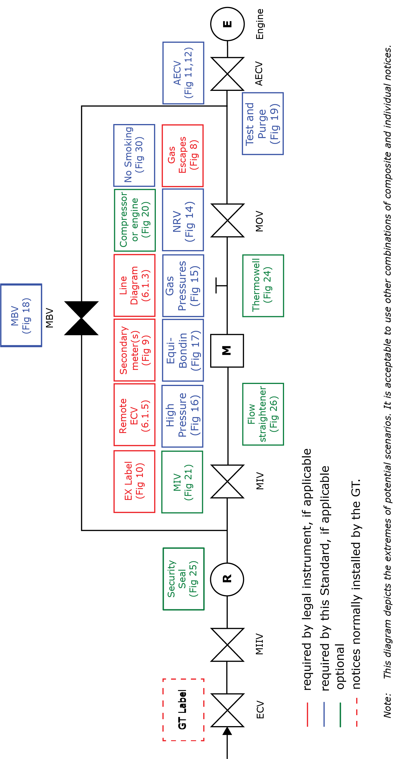

FIGURE 1 ─ POSITIONING OF NOTICES (TYPICAL ARRANGEMENT).
ALL INDIVIDUAL NOTICES

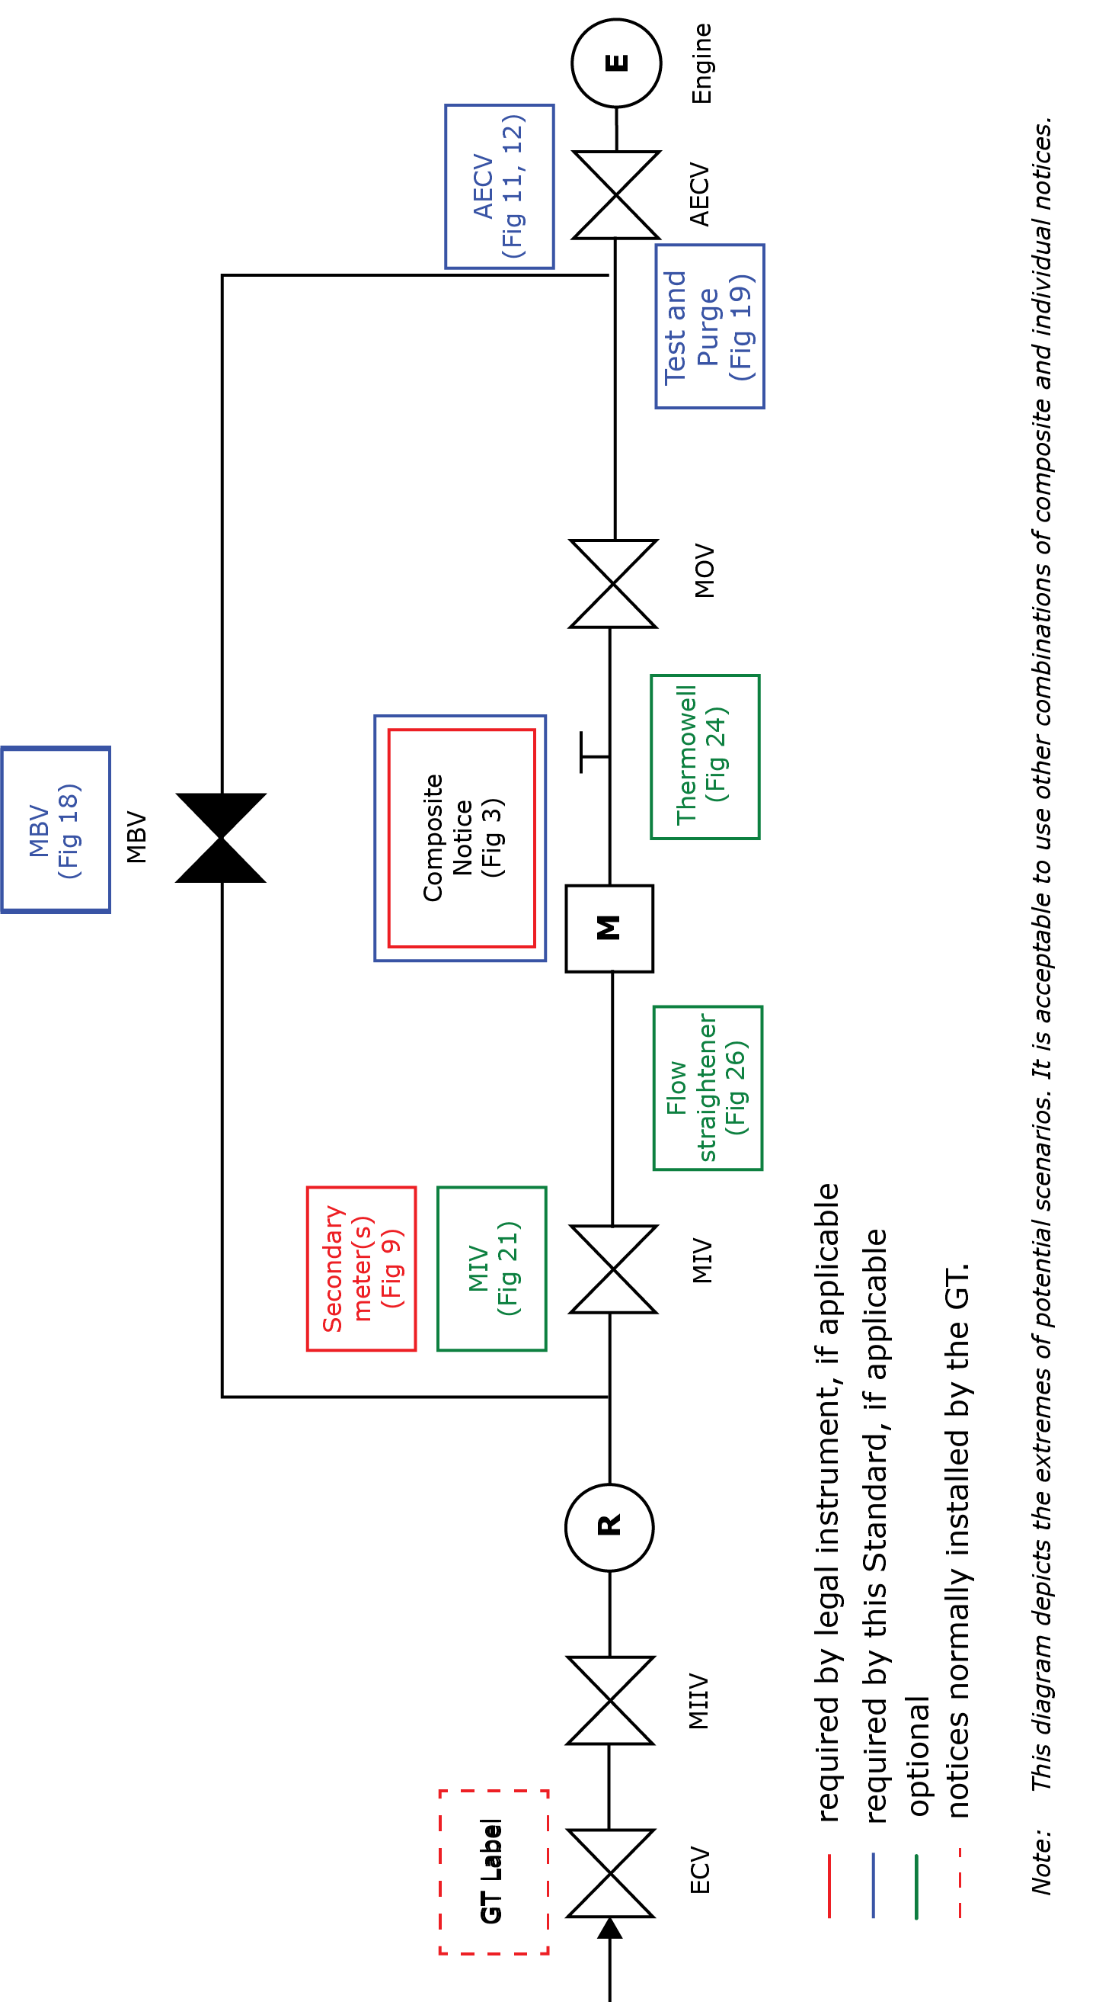

FIGURE 2 ─ POSITIONING OF NOTICES (TYPICAL ARRANGEMENT).
COMPOSITE NOTICE PLUS INDIVIDUAL NOTICES
SECTION 5 : COMPOSITE NOTICES

A composite notice is not a substitute for all notices. However, when placed in a prominent position, within sight of the meter and ECV, it does satisfy the requirements and options for the following notices:
    - suspected gas escapes (clause 6.1.1)
    - line diagram (clause 6.1.3)
    - remote meter (from ECV) (clause 6.1.5)
    - non-return valves (NRVs) (clause 7.1.1)
    - gas pressures (clause 7.1.2)
    - MOP downstream of the meter installation exceeding 75 mbar (clause 7.1.3)
    - equipotential bonding (clause 7.1.4)
    - gas compressors and gas engines (Sub-Section 8.2)
    - security seals (Sub-Section 8.6).

It may also satisfy the requirements for:
      - an explosive atmosphere (EX) label (clause 6.1.4)
      - “no smoking” and “gas escapes” (Sub-Section 10.1).

Figure 3 provides a typical example of this comprehensive composite notice.

  - Where MOP downstream exceeds 75 mbar, either an overlay or indelible writing shall be applied to the elevated outlet Section of the composite label (as shown in Figure 3). A typical example of this overlay is shown in Figure 7.

  - Where a composite notice includes pre-printed information that will vary from installation to installation, consideration shall be given to the provision of pre-printed or blank “overlays”. Most frequently, this will apply to the line diagram element of the notice and the warning concerning high pressure supply. Figures 4, 5 and 6 illustrate typical pre-printed overlays.

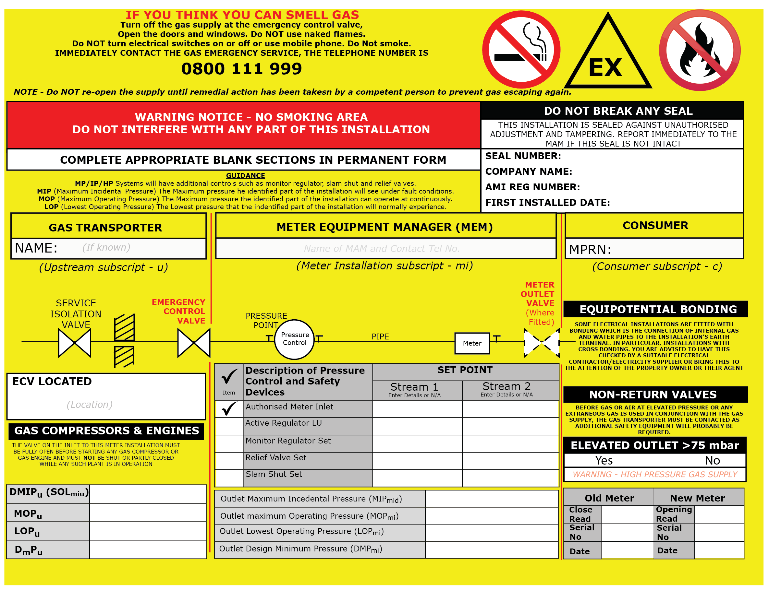
Minimum Size: A3

FIGURE 3 ─ TYPICAL COMPOSITE NOTICE

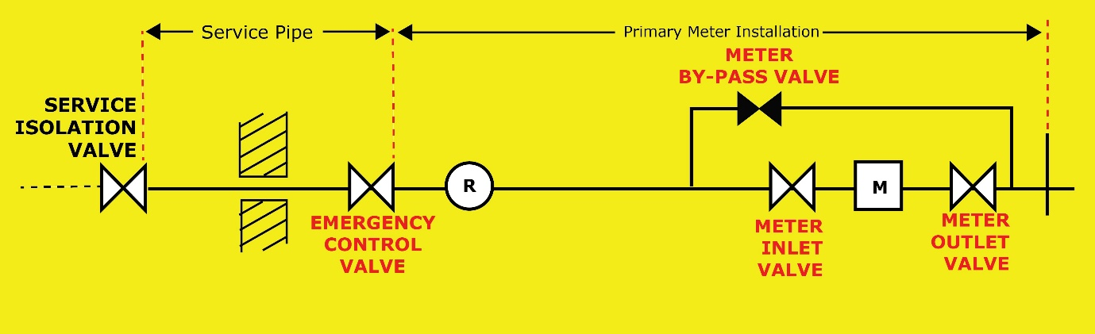

Size to match diagram in Figure 3.

FIGURE 4 - TYPICAL OVERLAY FOR A COMPOSITE NOTICE.
TWIN STREAM REGULATOR INSTALLATION

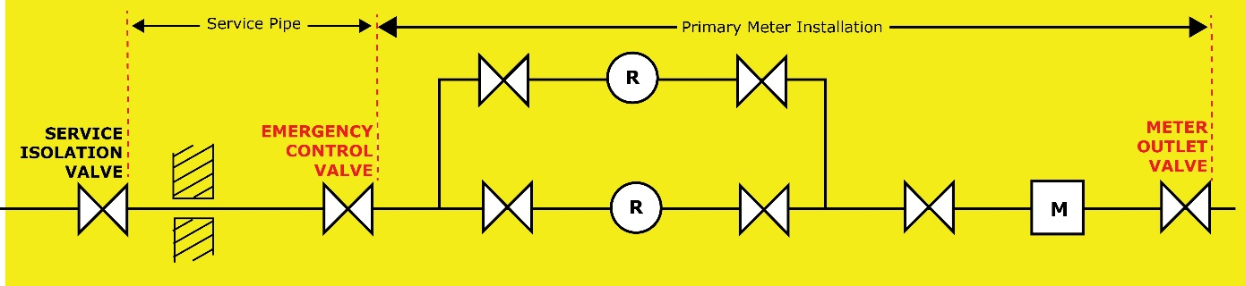

Size to match diagram in Figure 3.

FIGURE 5 - TYPICAL OVERLAY FOR COMPOSITE NOTICE.
SINGLE STREAM REGULATOR INSTALLATION WITH METER BY-PASS

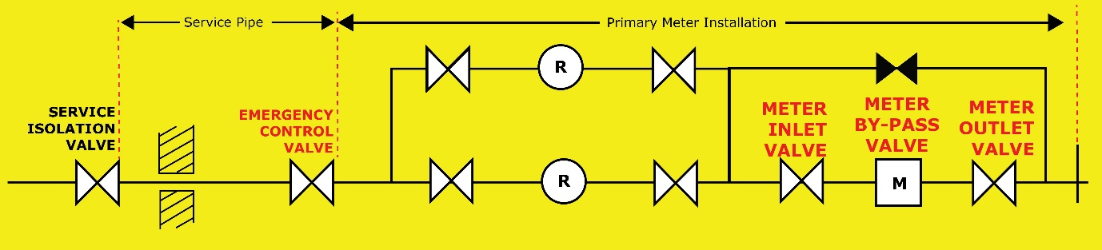

Size to match diagram in Figure 3.

FIGURE 6 - TYPICAL OVERLAY FOR A COMPOSITE NOTICE.
TWIN STREAM REGULATOR INSTALLATION WITH METER
BY-PASS

WARNING - HIGH PRESSURE GAS SUPPLY

Size to match elevated outlet section in Figure 3.

FIGURE 7 - TYPICAL OVERLAY FOR WARNING OF HIGH PRESSURE GAS SUPPLY

SECTION 6 : NOTICES THAT ARE REQUIRED BY LEGAL INSTRUMENT

  - NOTICES TO BE PROVIDED EITHER AS INDIVIDUAL NOTICES AND/OR AS PART OF A COMPOSITE NOTICE

6.1.1 Suspected gas escapes (under GS(I&U)R)
Any primary meter installation must be labelled to advise on the action to be taken in the event of a suspected gas escape. Either an individual notice, detailing the information given in Figure 8, must be prominently mounted near the primary meter or such notice must be included in a composite notice fitted near the relevant primary meter (see Section 5).



Minimum size A7 landscape.
Note: Also refer to Sub-Sections 4.3 and 4.4.

FIGURE 8 - TYPICAL NOTICE OF ACTION TO BE TAKEN IN THE EVENT OF A SUSPECTED GAS ESCAPE

6.1.2 Secondary meters (under GS(I&U)R)
When a secondary meter(s) is/are installed downstream of a primary meter, either an individual notice, detailing the information given in Figure 9, must be prominently mounted on or near the primary meter or such notice must be included in a composite notice fitted near the relevant primary meter (see
Section 5).

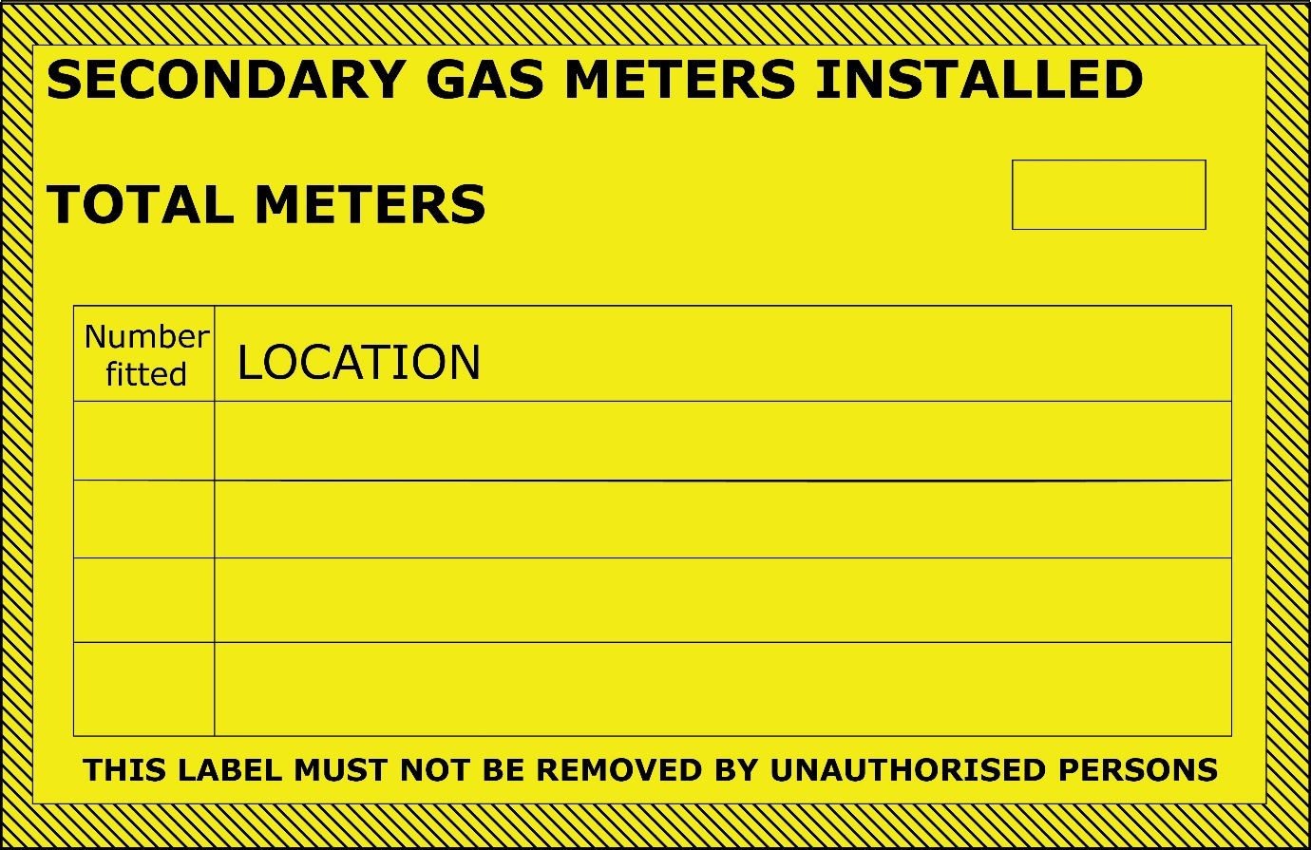
Minimum size A6 landscape.

Note: For location, insert detail, for example flat numbers, kitchen, etc.

FIGURE 9 - TYPICAL NOTICE OF SECONDARY METERS

6.1.3 Line diagrams (under GS(I&U)R, PSSR or this Standard)
6.1.3.1 GS(I&U)R require that, under certain circumstances, a line diagram of the meter installation be provided adjacent to the meter, in which case such a diagram must be fitted. In any event, a line diagram shall be fitted as if GS(I&U)R applied.

Note 1: It is permitted to provide an individual notice and include the diagram on a composite notice (see Section 5) and, for more complex installations, the appropriate overlay sticky label may be applied over the single stream diagram.

Note 2: Similarly, GS(I&U)R Regulations 17 and 24 may require a line diagram of the system downstream of the meter installation. In particular, where a secondary/sub-deduct meter(s) is/are installed, the line diagram needs to show the position of all the meters and their isolation valves and this is the responsibility of the secondary/sub-deduct meter owner.

      - Where a composite notice is not installed and for more complex installations when a line diagram cannot be fitted onto the notice, a line diagram detailing the meter installation layout and its components shall be provided as an individual notice.
      - Where PSSR apply (see Section 3), a diagram showing the installation shall be displayed, clearly marked with the safe operating limits and demarcation of responsibility for the entire system.

    - ATEX/UKCA EX (under DSEAR)

An individual notice, bearing the mark EX, of the form shown in Figure 10, must be installed at the entrance to any hazardous area.

Note: In a minority of installations, a composite notice (see Section 5) may be installed at this entrance to a hazardous area in which case it may be acceptable to incorporate this notice (without reducing its size or colour) in the composite notice and not include it as an individual notice.

Minimum dimensions 80 mm x 80 mm x 80 mm (may be bigger as appropriate).

Note: Also refer to Sub-Sections 4.3 and 4.4.

FIGURE 10 - EX LABEL

6.1.5 Remote ECV (from meter) (under GS(I&U)R)

Where a meter is either more than 2 m from, or out of sight of, the nearest upstream emergency control in the premises, a notice must be prominently displayed on or near the said meter or such notice must be included in a composite notice fitted near the relevant primary meter (see Section 5), indicating the position of that emergency control.

Note: A suitable variant of the notice shown in Figure 12 can be used.

6.2 NOTICES TO BE PROVIDED AS AN INDIVIDUAL NOTICE

6.2.1 Additional emergency control valve(s) (AECV(s)) (under GS(I&U)R)

For every valve designated an AECV within a meter installation (see IGEM/G/1), a notice, detailing the information given in Figure 11, must be secured to each AECV.

Note 1: The AECV(s) need(s) to be shown on the line diagram (see clause 6.1.3).

Note 2: Notices for any AECV downstream of a meter installation are covered in BS 6891 and IGEM/UP/2, as appropriate.

The labelling of an AECV within a meter installation is the responsibility of the MAM. Where an AECV is positioned outside the meter installation, the responsibility lies elsewhere, for example with the party installing installation pipework. If the MAM identifies a deficiency in the labelling of an AECV not within the meter installation, the matter should be referred to the responsible party. In addition, the method to be used to close the valve must be indicated.

Note 3: Normally, this is achieved by using ON/OFF tape wrapped around the pipe adjacent to the AECV. Figure 12 shows a typical section of such tape for a lever-operated valve. Suitable alternative labelling is required for other valve types, for example a gate valve when the marking may be in the form of instructions on the handwheel.

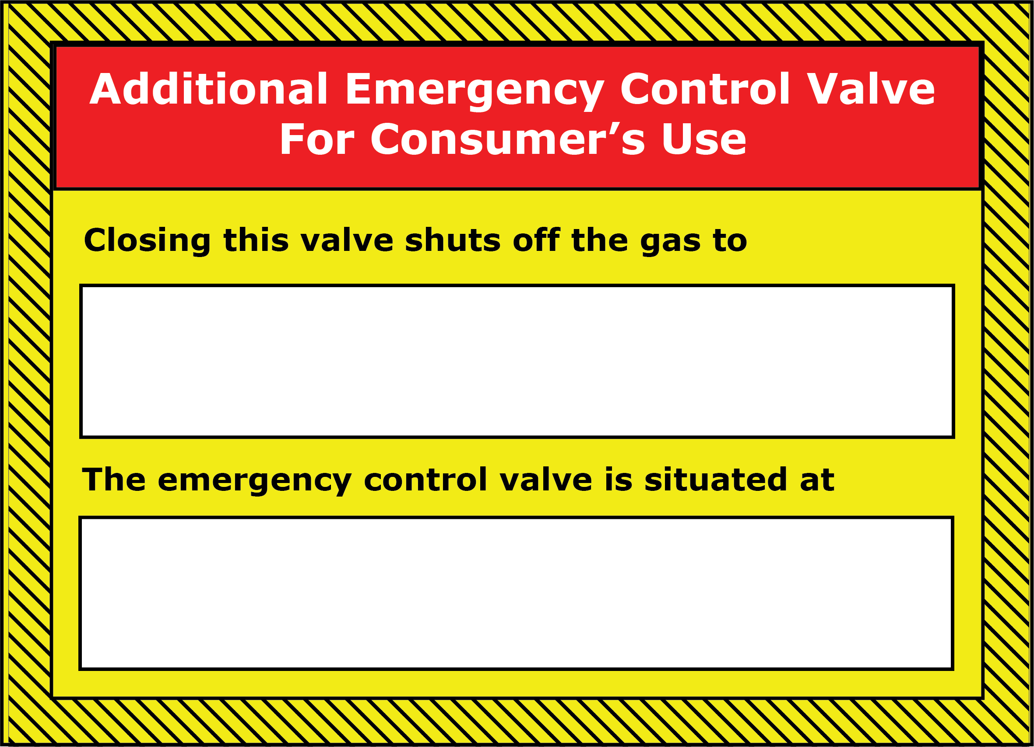FRONT

REAR
Minimum size A6 landscape.

Note 1: The notice can be separated into two, if required.

Note 2: On the front, insert detail of the parts of the installation isolated by the valve, for example flat numbers, kitchen, etc. Also insert detail of the location of the ECV fitted upstream of the AECV.

FIGURE 11 - TYPICAL LABELLING OF AN AECV

Minimum width of tape, 50 mm

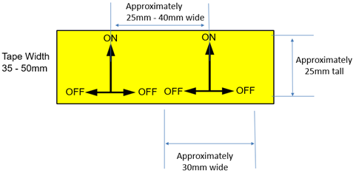

FIGURE 12 - TYPICAL LABELLING OF DIRECTION OF OPERATION OF AN AECV LEVER TYPE VALVE

    - ECV

The labelling of the ECV is the responsibility of the GT and is covered in IGEM/TD/4 (see Figure 13 for a substitute label).

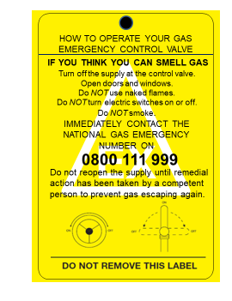

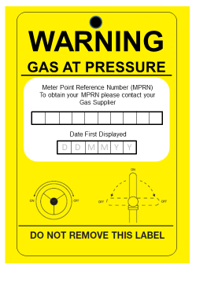
FIGURE 13 – SUBSTITUTE ECV LABEL
SECTION 7 : NOTICES THAT ARE REQUIRED BY THIS STANDARD

7.1 NOTICES TO BE PROVIDED AS INDIVIDUAL NOTICES AND/OR AS PART OF A COMPOSITE NOTICE

7.1.1 Non-return valves (NRVs)

Where an NRV is required to protect the upstream Network, a notice detailing the information given in Figure 14, shall be secured close to the outlet of the meter installation.
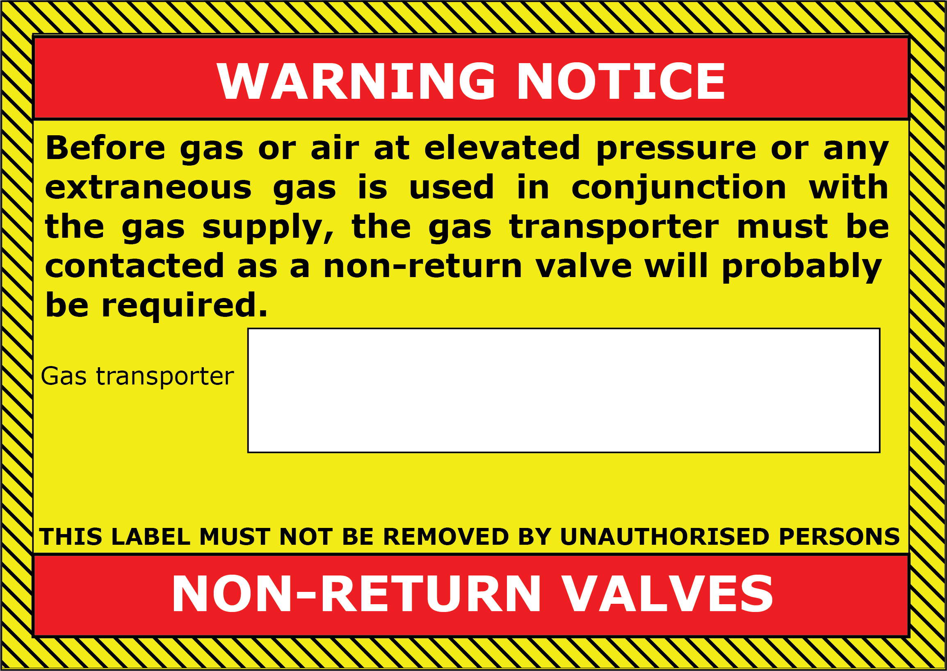

Minimum size A7 landscape.

Note: The NRV itself may be installed at the point of gas use.

FIGURE 14 - TYPICAL NOTICE OF PROTECTION OF THE NETWORK

7.1.2 Gas pressures

A notice, detailing the information given in Figure 15, shall be attached to the meter inlet valve (MIV) or close to the inlet of the meter.

Note: The authorised meter inlet pressure is the set pressure registered at the meter inlet and is the contractual pressure agreed with the GT, the shipper/supplier and the consumer. For supplies where the pressure is not regulated, write in “NOT REGULATED”.
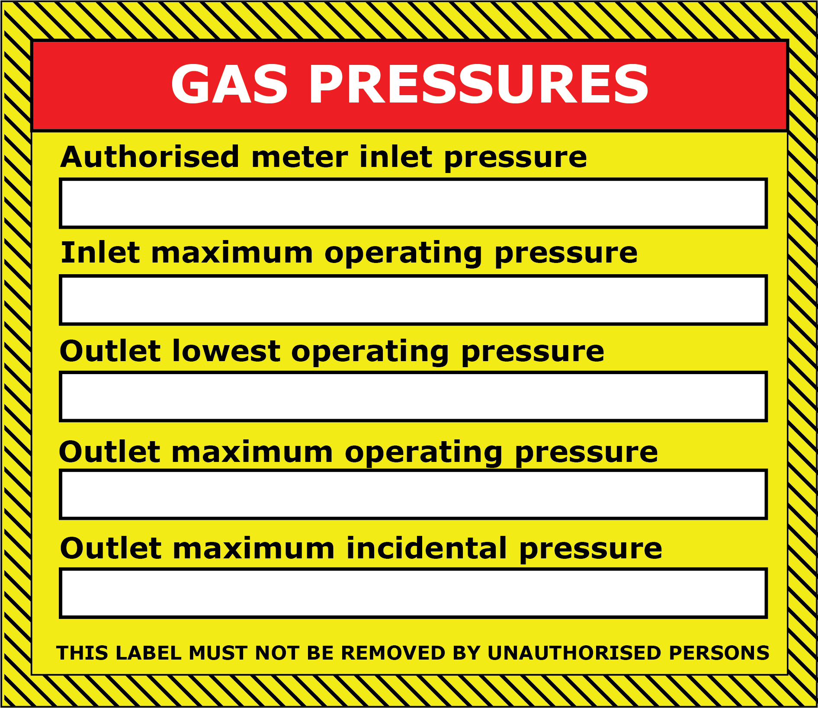
Minimum size A6 landscape.

Note: Also refer to Sub-Sections 4.3 and 4.4.

FIGURE 15A - TYPICAL NOTICE OF GAS PRESSURES

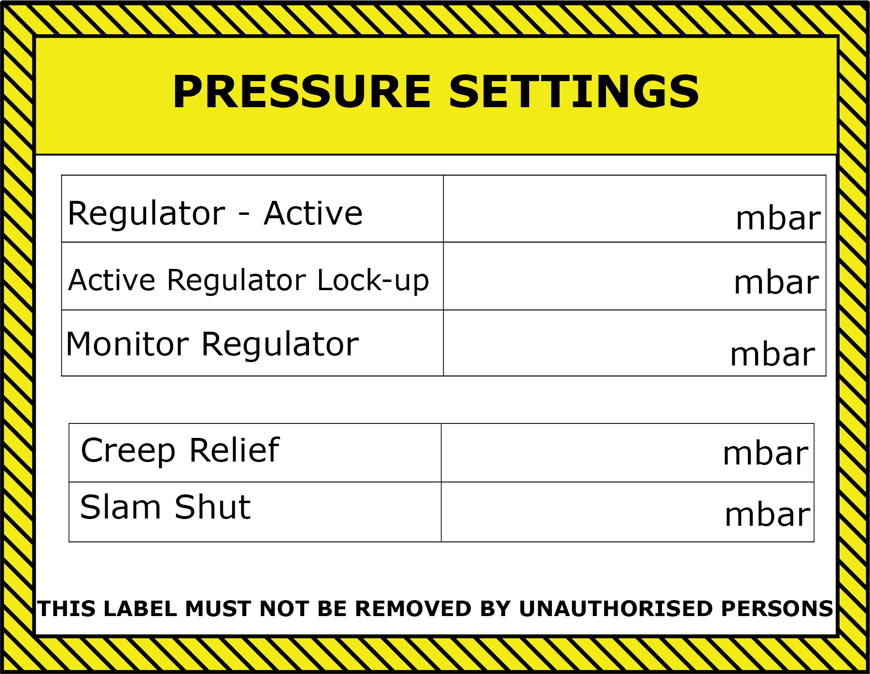

Minimum size A6 landscape.

Note: Also refer to Sub-Sections 4.3 and 4.4.

FIGURE 15B - TYPICAL NOTICE OF GAS PRESSURES

    - Notice of MOP downstream of the meter installation exceeding 75 mbar

A notice, detailing the information given in Figure 16, shall be attached to, or adjacent to, the meter when MOP downstream of the meter installation exceeds 75 mbar.

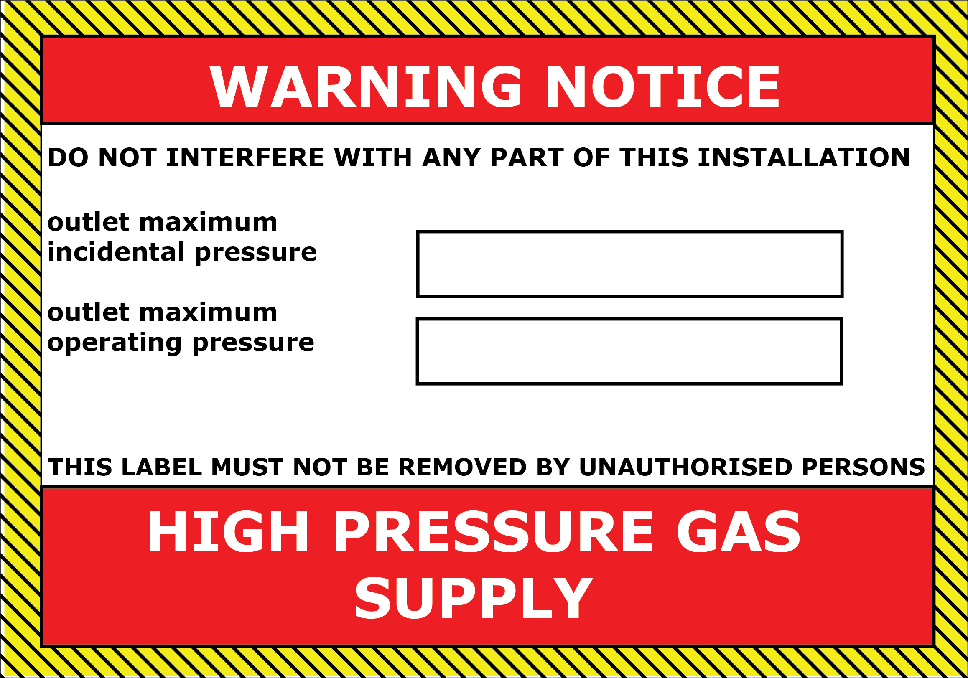

Minimum size A6 landscape.

FIGURE 16 - TYPICAL NOTICE OF MOP DOWNSTREAM OF THE METER INSTALLATION EXCEEDING 75 mbar

    - Protective equipotential bonding

A notice, containing details as given in Figure 17, shall be attached near the meter.

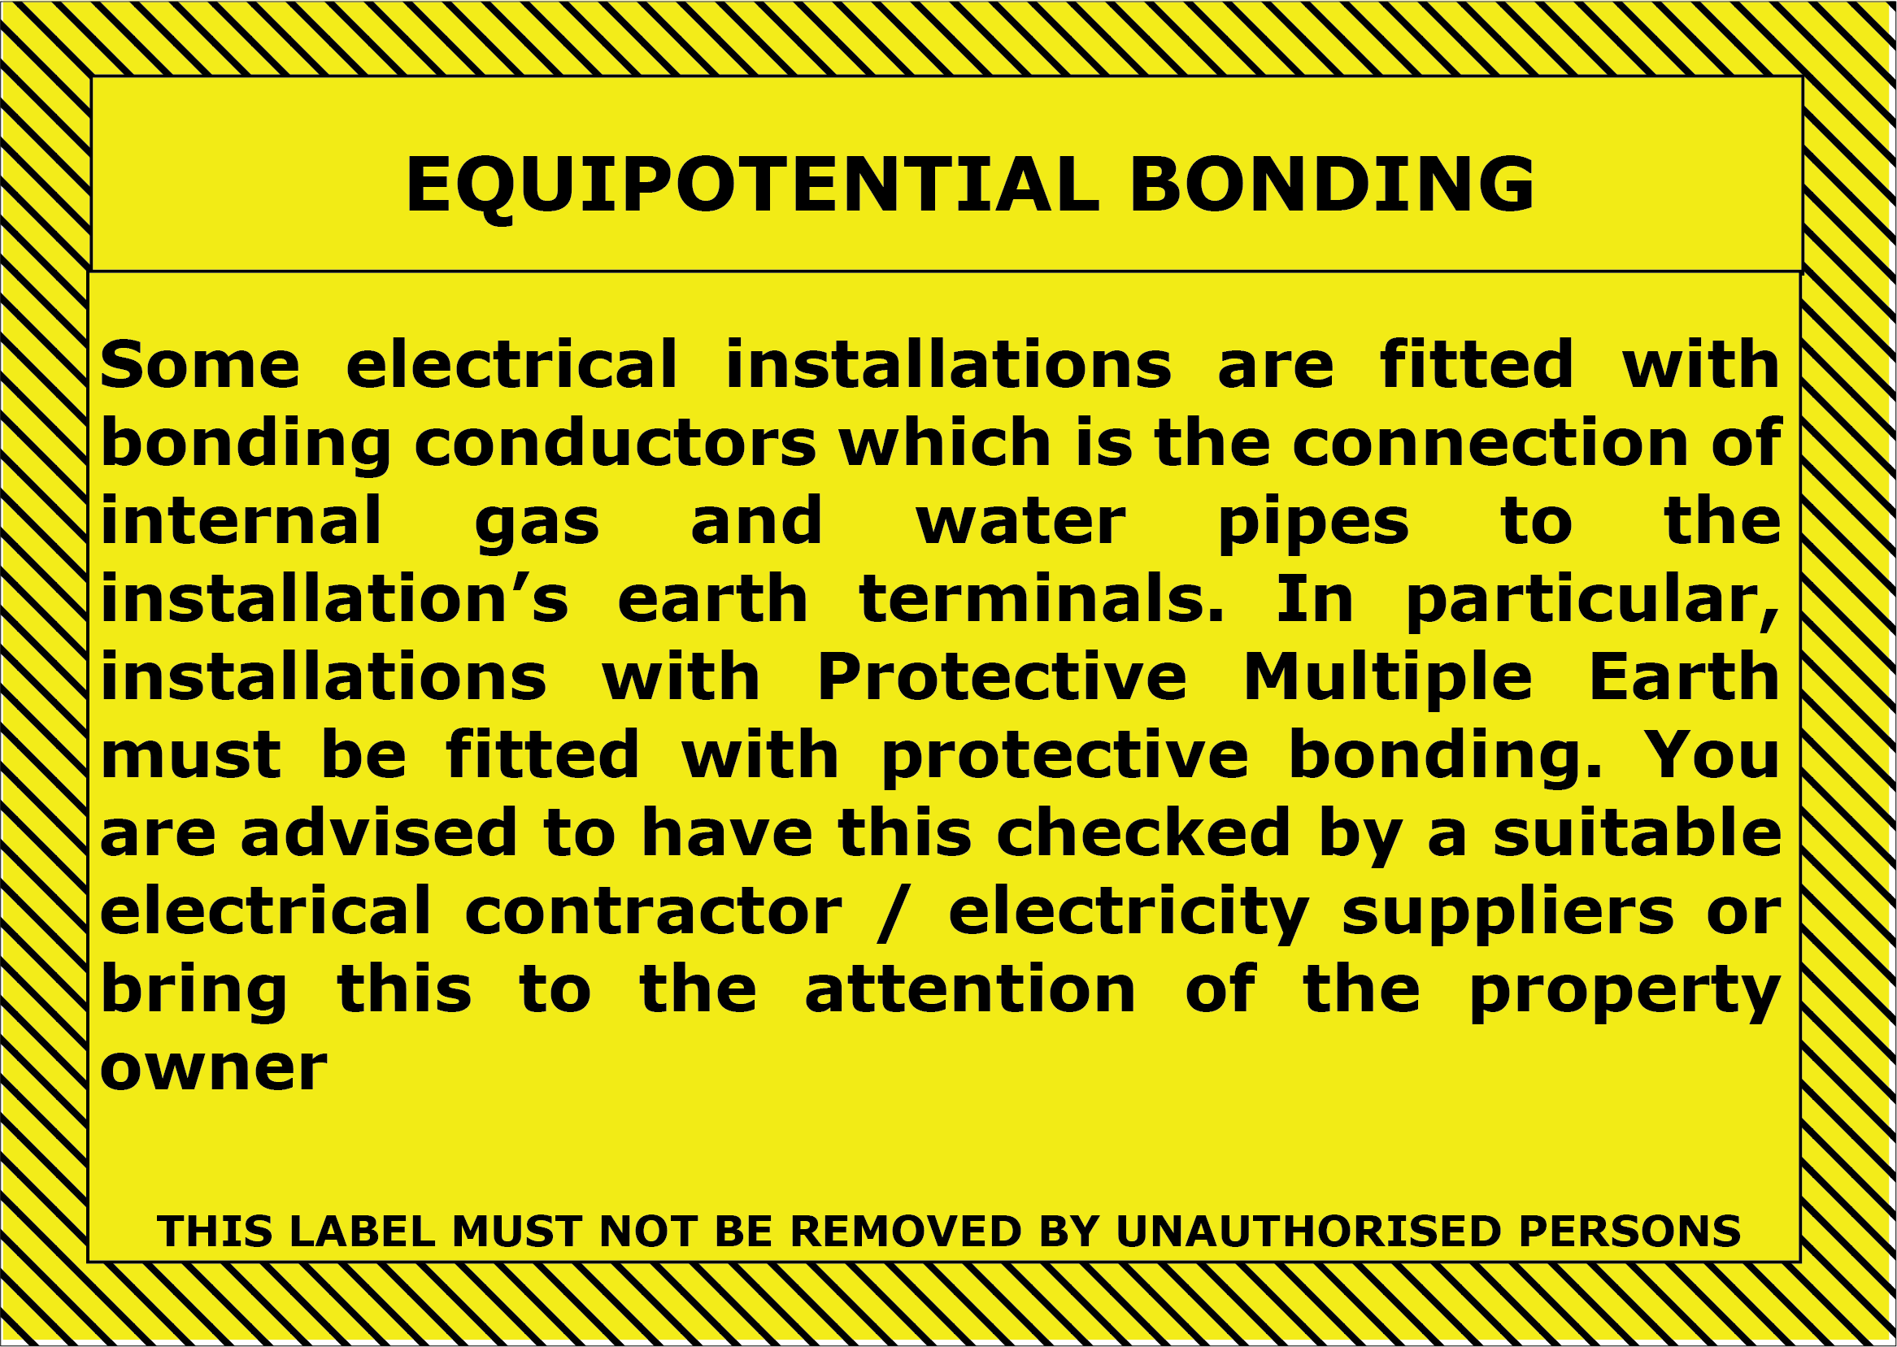

Minimum size A6 landscape.

FIGURE 17 - TYPICAL NOTICE FOR PROTECTIVE EQUIPOTENTIAL BONDING

  - NOTICES TO BE PROVIDED AS AN INDIVIDUAL NOTICE

    - Meter by-pass valve (MBV)

Where an installation contains a MBV, an individual notice, as shown in Figure 18, shall be attached to the valve.

Note: Although details may be included in a composite label, an individual notice is always required. However, the by-pass and valve need to be shown in the line diagram (see clause 6.1.2).

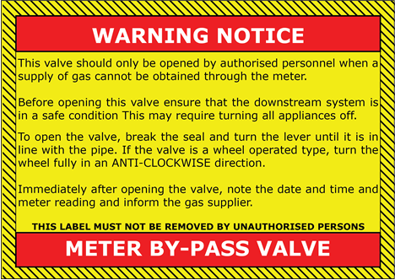
Minimum size A6 landscape.

FIGURE 18 - TYPICAL NOTICE OF A METER BY-PASS VALVE (MBV)

7.2.2 Testing, purging and commissioning

Once a meter installation has been strength and tightness tested, purged and commissioned, and is not connected to the installation pipework, a notice, containing details as given in Figure 19, shall be attached near the outlet of the meter installation.

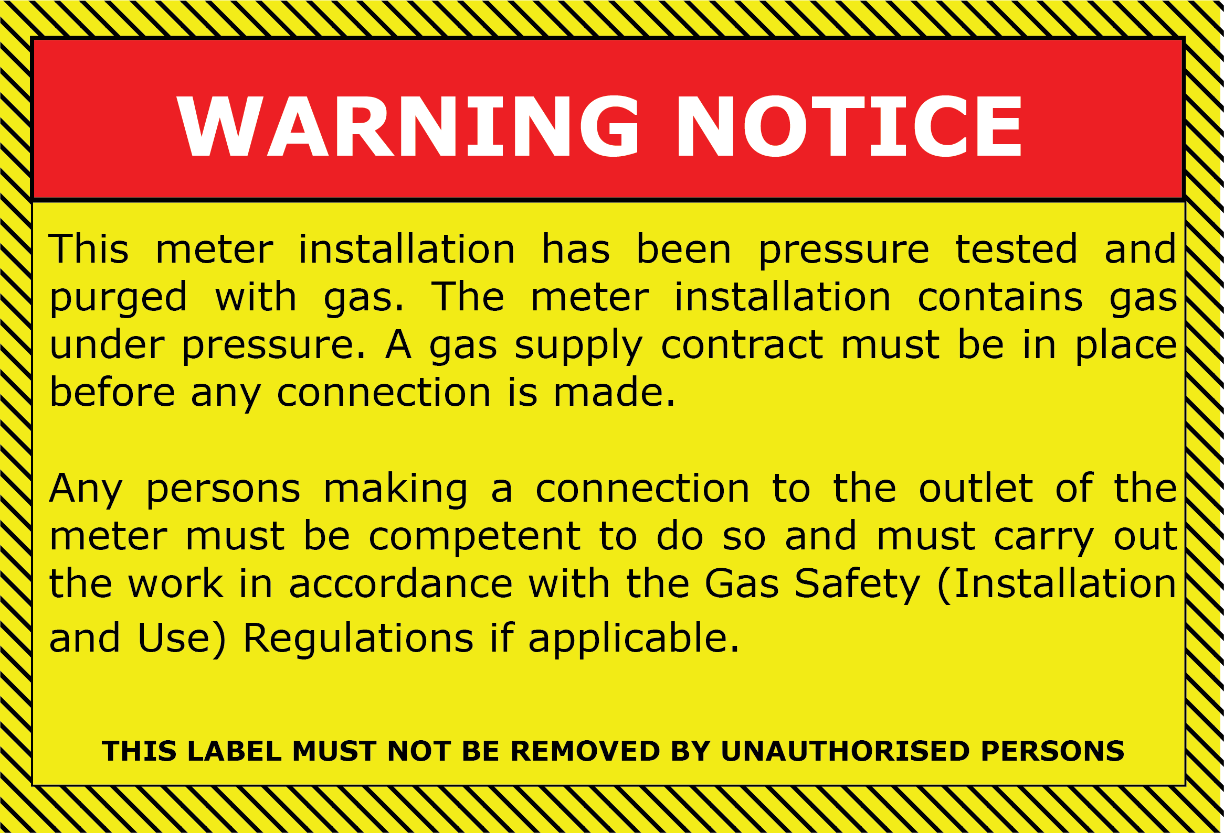
Minimum size A6 landscape.

Note: See also Sub-Sections 4.3 and 4.4.

FIGURE 19 - TYPICAL NOTICE AFTER TESTING, PURGING AND
COMMISSIONING
SECTION 8 : OPTIONAL NOTICES

8.1 The provision of the following notices is optional. However, where a notice is fitted, it shall not be allowed to give incorrect information, i.e. it shall be updated with subsequent changes by the party undertaking the work.

8.2 GAS COMPRESSORS AND GAS ENGINES

For any meter installation where the downstream system may include a gas compressor or gas engine, either an individual notice, detailing the information given in Figure 20, should be secured close to the outlet of the meter installation, or such notice should be included in a composite notice fitted at the installation (see Section 5).

Note: In any event, such a label has to be fitted at the location of the relevant compressor or engine (see IGEM/UP/3 and IGEM/UP/6).
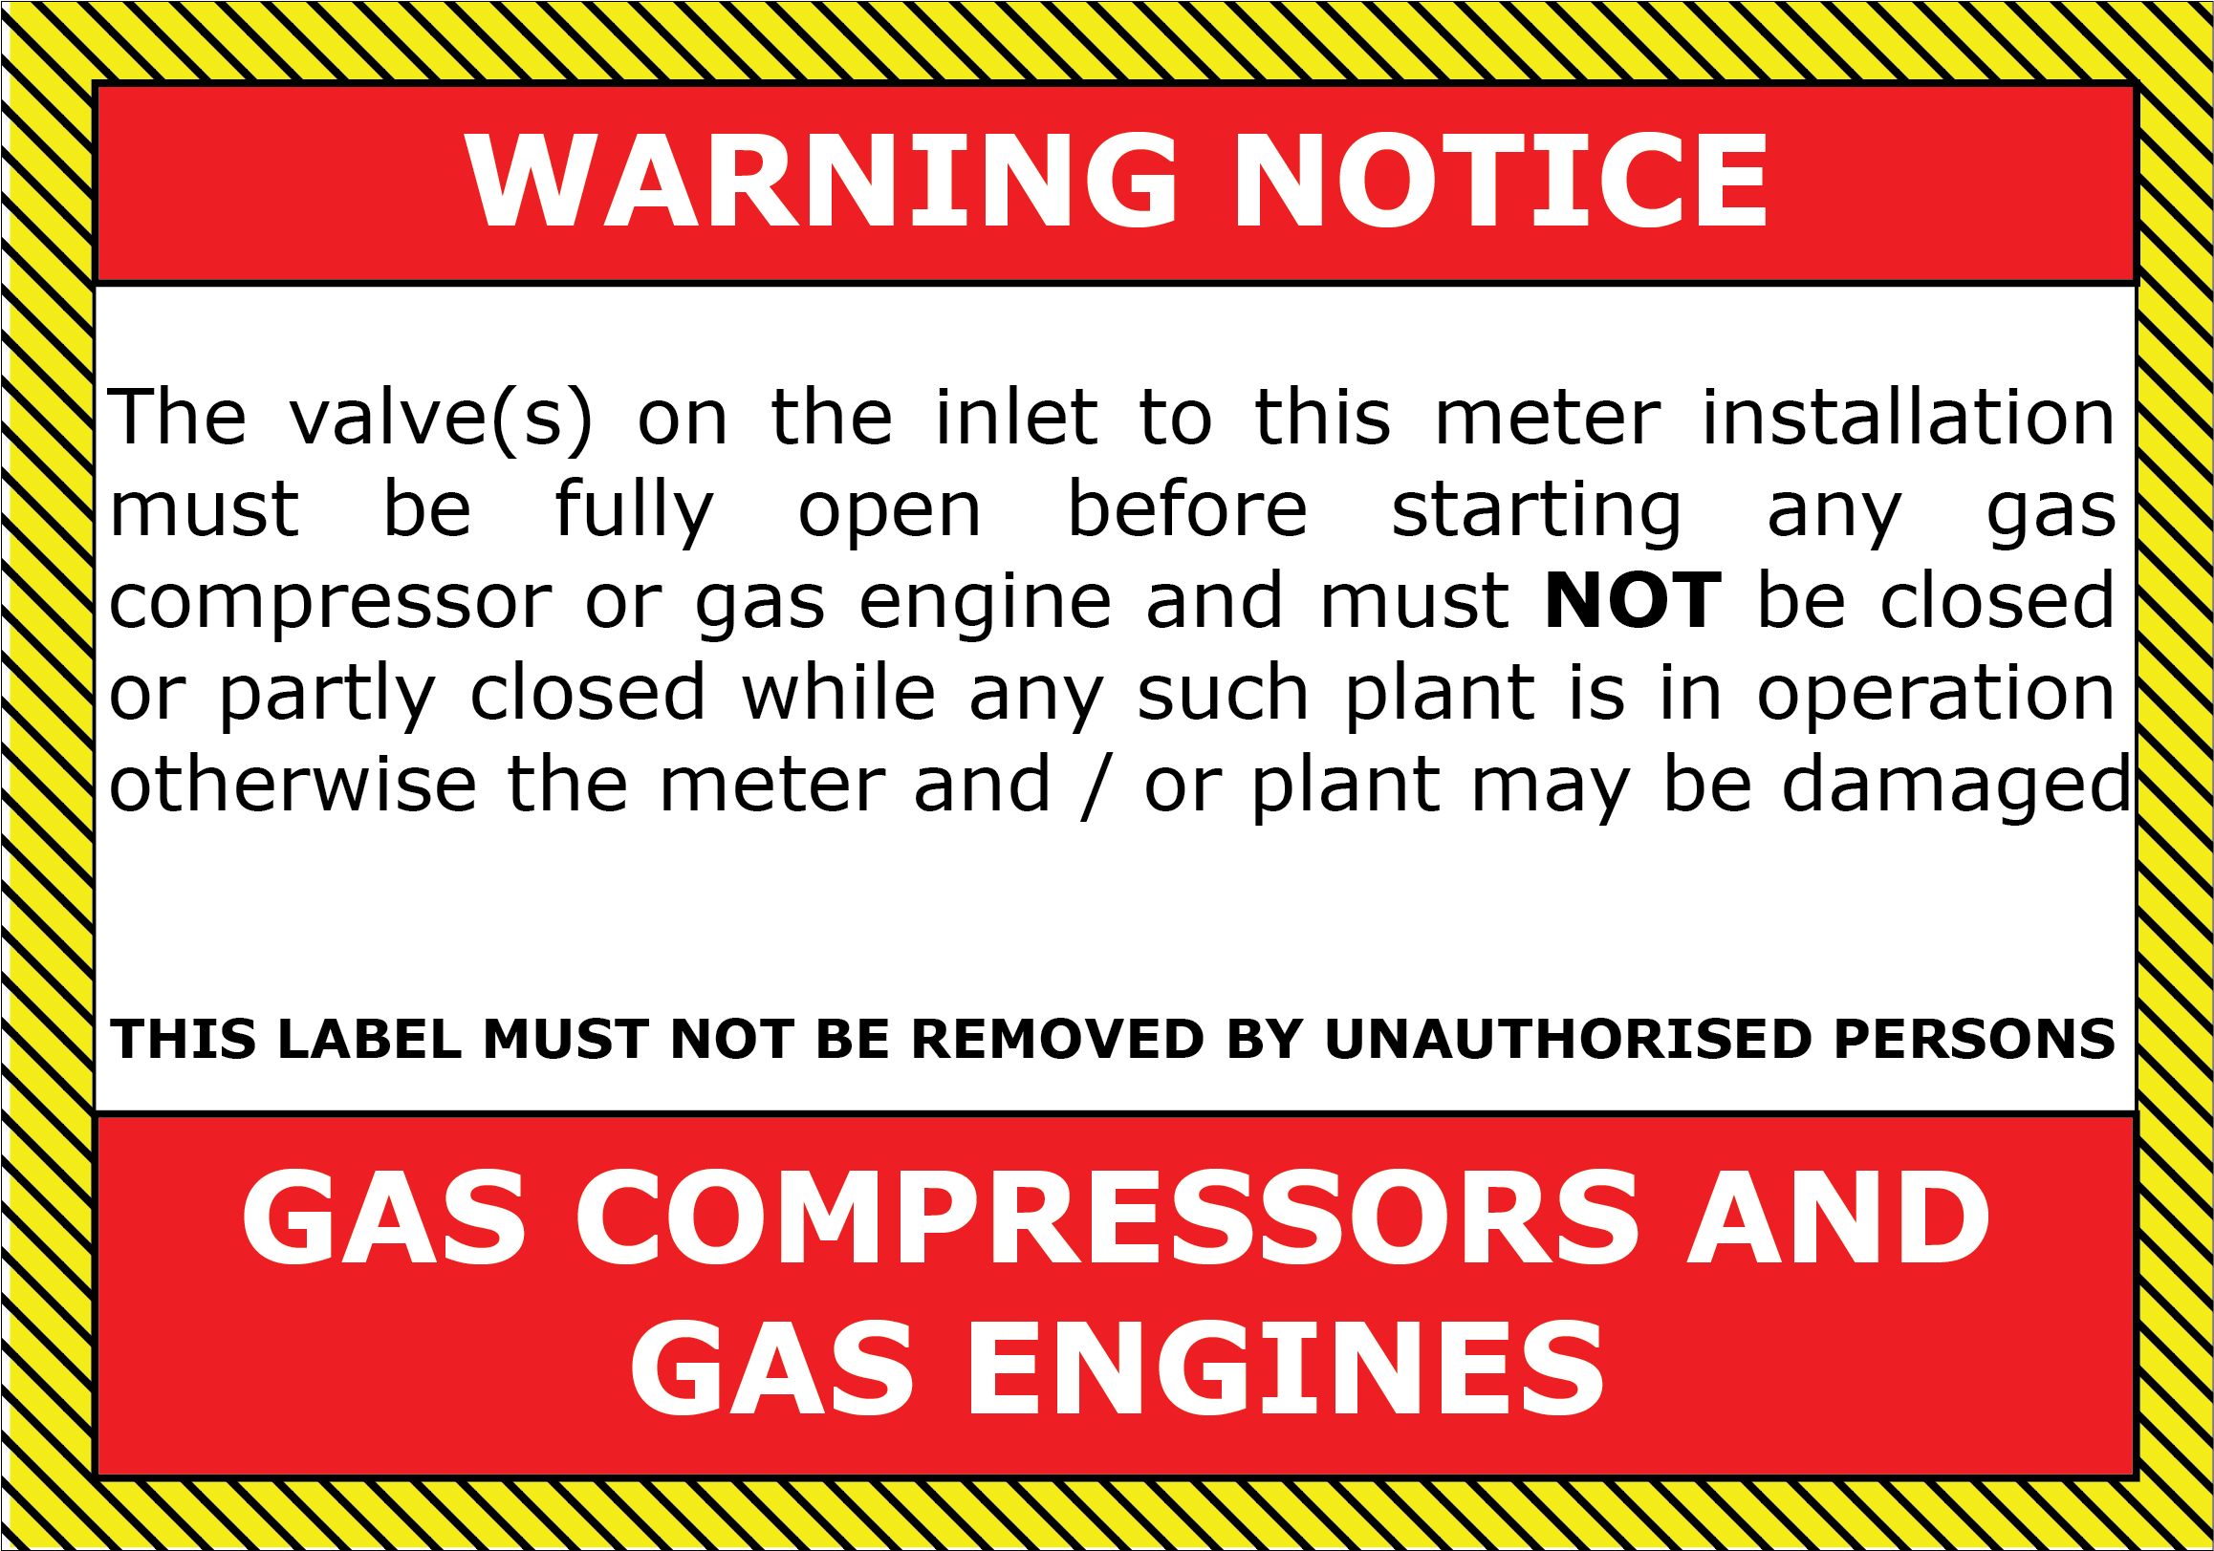
Minimum size A6 landscape.

FIGURE 20 - TYPICAL NOTICE AT THE METER INSTALLATION OF A GAS COMPRESSOR OR ENGINE

8.3 VALVE IDENTIFICATION FOR MULTIPLE VALVE INSTALLATIONS

Where an installation contains a number of valves that could cause confusion, individual notices, containing appropriate details, should be attached, for example to the:
    - meter inlet valve (MIV)
    - meter outlet valve (MOV)
    - meter installation inlet valve (MIIV).

Figure 21 provides an example of an MIV notice.



Minimum size A7 landscape.

FIGURE 21 - TYPICAL NOTICE OF A METER INLET VALVE

8.4 STREAM IDENTIFICATION

Where an installation contains more than one regulator or meter stream, notices, containing details as given in Figures 22 and 23, should be attached to the appropriate stream.

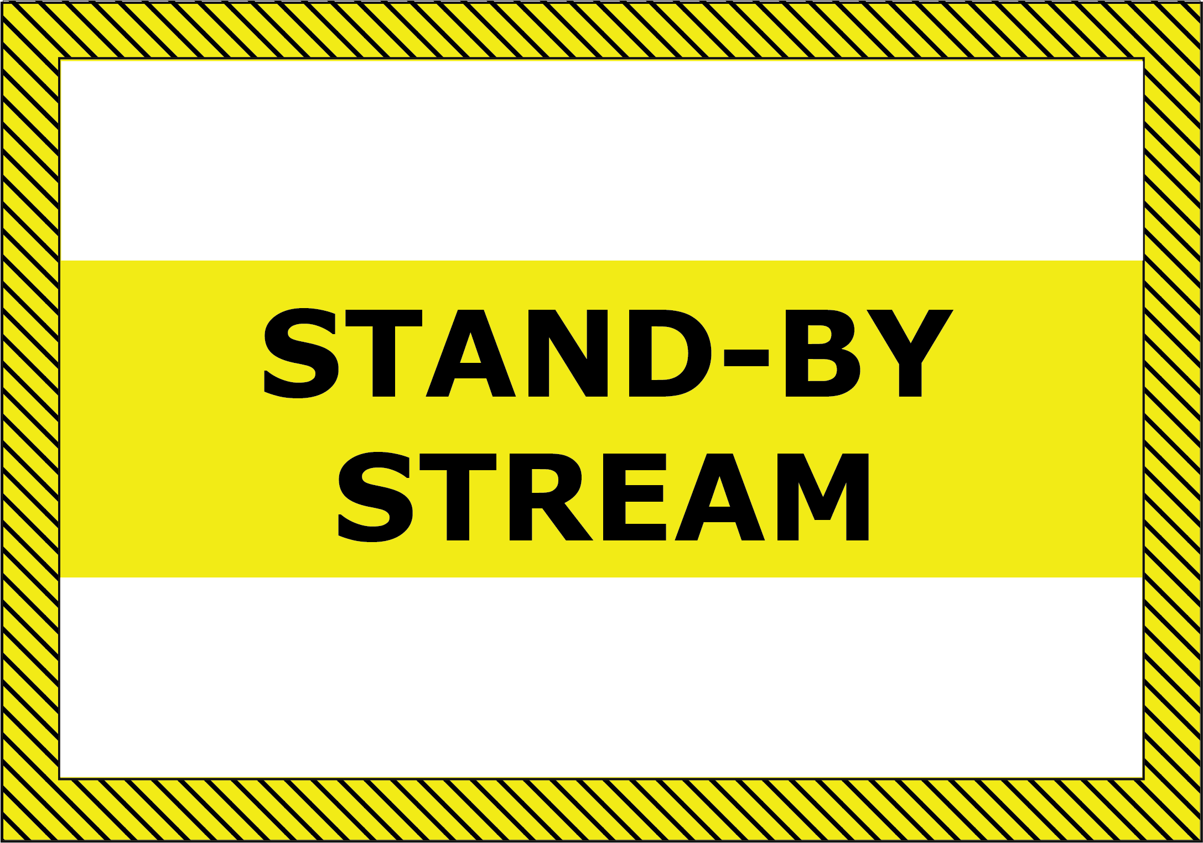
Minimum size A7 landscape.

FIGURE 22 - TYPICAL NOTICES FOR MULTIPLE STREAMS FOR THE
PURPOSE OF CONTINUITY OF SUPPLY




Minimum size A7 landscape.

FIGURE 23 - TYPICAL NOTICES FOR MULTIPLE STREAMS FOR THE PURPOSE OF ACHIEVING CAPACITY

8.5 THERMOWELLS

Where an installation has a thermowell installed, a notice, containing details as given in Figure 24, should be attached to the plug or probe.

Note: Pipeline connections which are bushed down and plugged can be mistaken for a plugged thermowell. This is a hazard where plugs are removed under pressure in the belief that a thermowell has been installed.



Minimum size A7 landscape.

FIGURE 24 - TYPICAL NOTICE FOR A THERMOWELL

8.6 SECURITY SEALS

Where a fitting is sealed against adjustment and tampering, a notice, containing the approved meter installer (AMI) seal number as given in Figure 25, should be attached near the fitting, by a sealing wire or tie or such a notice should be included in a composite notice fitted at the installation.
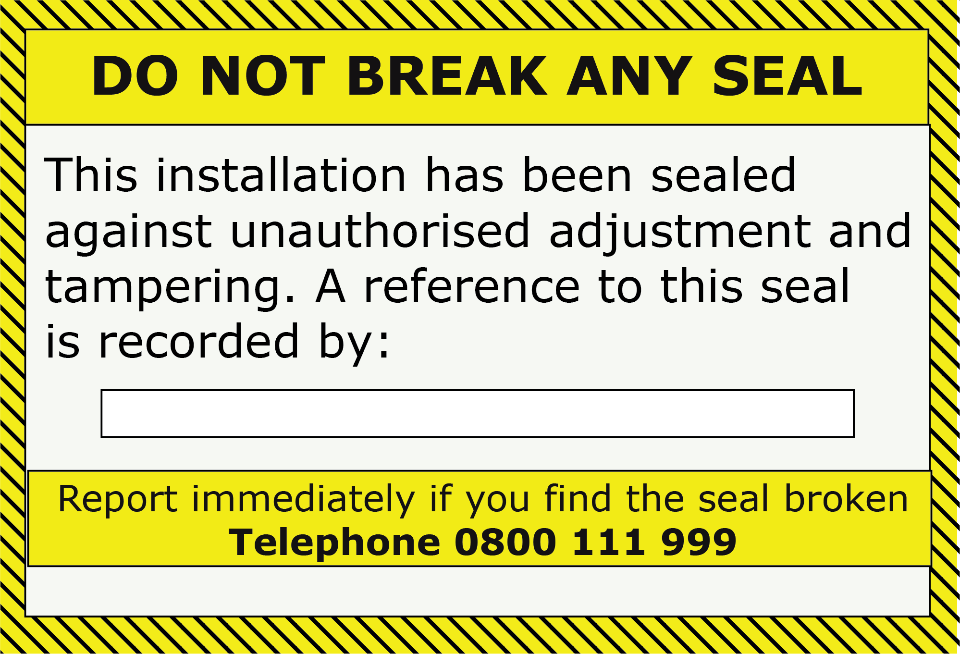

Minimum size A7.

Note: Also refer to Sub-Section 4.3.

FIGURE 25 - TYPICAL NOTICE FOR A SECURITY SEAL

8.7 FLOW STRAIGHTENERS (turbine meters only)

For a turbine meter installation which contains a flow straightener(s) within the installation, a notice should be fitted to indicate the position of the straightener(s), as given in Figure 26.

Minimum width of tape, 50 mm.

Note: Also refer to Sub-Section 4.3.

FIGURE 26 - TYPICAL TAPE USED AS A NOTICE OF A FLOW
STRAIGHTENER

8.8 TESTING FROM THE METER INLET VALVE

For installations supplied at higher pressures, and incorporating an MIV, typically small I&C equipment, a notice should be provided to assist engineers working on the consumer’s system to carry out testing using the Meter Inlet Isolation Valve (MIV) as the isolation point for the testing. The MIV should also be labelled, refer to Figure 27.

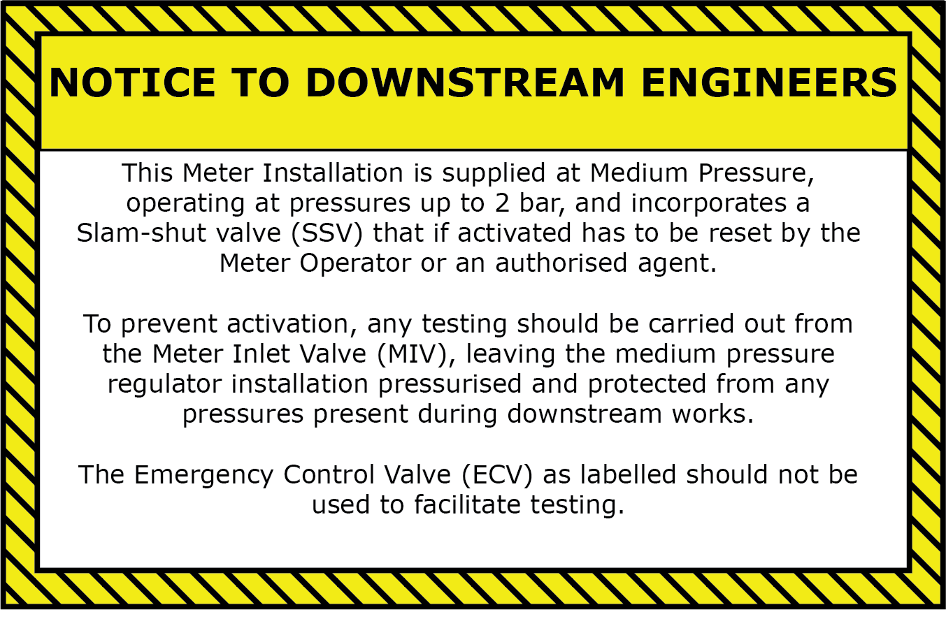
Minimum size A7.

FIGURE 27 – GUIDANCE FOR TESTING FROM THE MIV

SECTION 9 : PIPEWORK IDENTIFICATION AND COLOUR CODING

9.1 The meter installation pipework shall be readily identifiable as carrying NG. This shall be achieved by fully painting with yellow (to BS 4800 08 C 35) or yellow (to BS 4800 10 E 53) paint or by banding the pipe (which does not have to be so painted) with GAS marker tape (see Figure 28) or in accordance with BS 1710.

Note: For painting, it is common practice to use yellow BS 4800 08 C 35 for MOP_{u} not exceeding 75 mbar and BS 4800 10 E 53 yellow for MOP_{u} exceeding 75 mbar.

Minimum width of tape, 50 mm.

Note: Also refer to Sub-Section 4.3.
FIGURE 28 - TYPICAL GAS MARKER TAPE

9.2 Where marker tape is used, the positioning of gas banding should be as shown in Figure 29. Additional banding shall be provided as necessary to enable every section of pipework within the meter installation to be visibly identifiable.

FIGURE 29 - POSITIONING GAS MARKER TAPE
SECTION 10 : GENERAL HEALTH AND SAFETY NOTICES

  - NO SMOKING/GAS ESCAPES
A notice, containing details as given in Figure 30, shall be attached in a prominent position visible when entering any enclosure or compound containing a meter installation. However, where the attachment of such a notice would itself create a hazardous situation, for example by encouraging entry for unauthorised persons where vandalism is a possibility, the notice shall be prominently displayed inside the housing/compound and this may be as part of a composite notice (see Section 5) (see Figures 31 and 32).

Minimum size A4 landscape.

Note: See also Sub-Sections 4.3 and 4.4.

FIGURE 30 - TYPICAL “NO SMOKING” AND GAS ESCAPES NOTICE

  - PERSONAL PROTECTIVE EQUIPMENT (PPE)

PPE notices shall take into account the requirements detailed in MHSWR.

The following notices, as appropriate, must be prominently displayed at the entry into the housing/compound, warning of potential hazards created by the installation and indicating a requirement for the use of PPE and clothing (see Figures 31 and 32):
    - eye protection must be worn
    - ear protection must be worn
    - safety helmets must be worn
    - safety footwear must be worn
    - protective clothing must be worn.

Note: These labels are commercially available in standard form.

  - EMERGENCY EXITS
Notices indicating emergency exits and warnings to make sure that such exits are not obstructed shall be clearly visible and appropriately positioned (see Figures 31 and 32).

Note: These labels are commercially available in standard form.

  - LIFTING

For a prefabricated module, suitable lifting points shall be identified/marked permanently, for example by painting lifting eyes red.

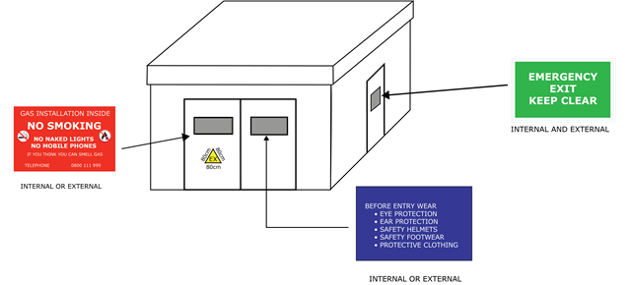
FIGURE 31 - TYPICAL POSITIONS OF HOUSING NOTICES

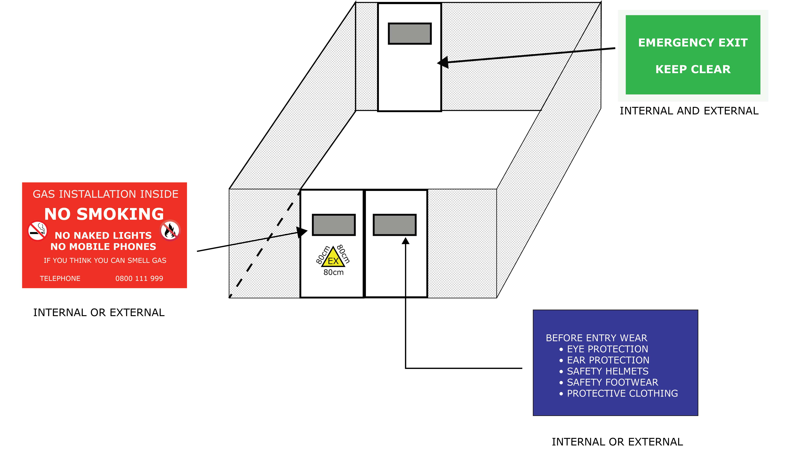

FIGURE 32 - TYPICAL POSITIONS OF COMPOUND NOTICES
SECTION 11 : DATA PLATES

  - For a prefabricated module, a data plate, containing the following details, shall be fitted in a prominent position.

  - Manufacturer’s name
  - Module model/type
  - Module serial number
  - Year of manufacture
  - Module weight (kg)
  - Module capacity (m³ h⁻¹) and designed flow range
  - Module strength test pressure (STP_{miu}) (mbar/bar)
  - STP_{mid}
  - Module inlet pressure range (MOP_{u} to LOP_{u}) (mbar/bar)
  - Module inlet design minimum pressure (DmP_{u}) (mbar/bar)
  - Module (outlet) MIP_{mi} (result of slam-shut setting) (mbar/bar)
  - Creep relief setting (mbar/bar)
  - Module (outlet) MOP_{mi} (maximum allowable active regulator setting)
(mbar/bar)
  - Module outlet PLOP_{mi} (based on the active regulator setting), if applicable
  - Module outlet TOP_{mi} (based on the monitor regulator setting) if applicable
  - Meter inlet pressure (mbar/bar)
  - Module outlet LOP_{mi} (mbar/bar)
  - Module outlet DmP_{mi} (mbar/bar).

  - For a site-fabricated module, a data plate containing all the following details shall be fitted in a prominent position:
  - module capacity (m³ h⁻¹) and designed flow range
  - module strength test pressure (STP_{u}) (mbar/bar)
  - module inlet pressure range (MOP_{u} to LOP_{u}) (mbar/bar)
  - module inlet design minimum pressure (DmP_{u}) (mbar/bar)
  - module (outlet) MIP_{mi} (result of slam-shut setting) (mbar/bar)
  - creep relief setting (mbar/bar)
  - module (outlet) MOP_{mi} (maximum allowable active regulator setting)
(mbar/bar)
  - monitor regulator setting plus accuracy class (AC) (TOP_{mi}) (mbar/bar) if applicable
  - meter inlet pressure (mbar/bar)
  - module outlet LOP_{mi} (mbar/bar)
  - module outlet DmP_{mi} (mbar/bar).

  - Where an in-service change is made to a module that invalidates the details on the data plate, appropriate details shall be updated by the party undertaking the work, in a clear and durable manner that obscures but does not destroy the original information.
11.4 METER REMOVAL

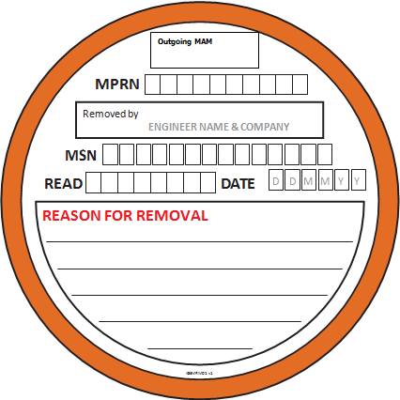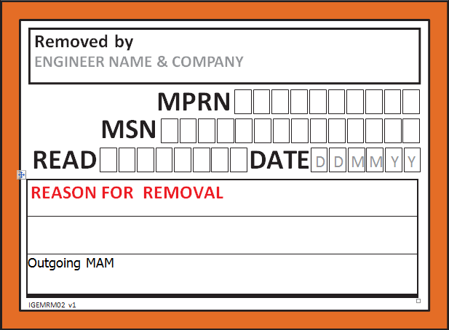

FIGURE 33 – TYPICAL LABELS FOR IDENTIFYING REMOVED METERING EQUIPMENT

APPENDIX 1 : GLOSSARY, ACRONYMS, ABBREVIATIONS, SYMBOLS, UNITS AND SUBSCRIPTS

A1.1 GLOSSARY

All definitions are provided in IGEM/G/4, which is freely available by downloading a printable version from IGEM’s website www.igem.org.uk.

Standard and legacy gas metering arrangements are given in IGEM/G/1, which is freely available by downloading a printable version from IGEM’s website.

A1.2 ACRONYMS AND ABBREVIATIONS

ACoP Approved Code of Practice
AC accuracy class
ACS Nationally Accredited Certification Scheme for Individual Gas Fitting Operatives
AECV additional emergency control valve
AMI approved meter installer
ATEX Atmospheres explosive
CoMCoP Consolidated Metering Code of Practice
CoP Code of Practice
DmP design minimum pressure
DSEAR Dangerous Substances and Explosive Atmospheres Regulations
ECV emergency control valve
ESP emergency service provider
EX explosive atmosphere
GB Great Britain
GS(I&U)R Gas Safety (Installation and Use) Regulations
GS(M)R Gas Safety (Management) Regulations
GT gas transporter
HSE Health and Safety Executive
HSWA Health and Safety at Work etc. Act
IGEM Institution of Gas Engineers and Managers
LOP lowest operating pressure
MAM meter asset manager
MBV meter by-pass valve
MHSWR Management of Health and Safety at Work Regulations.
MIP maximum incidental pressure
MIIV meter installation inlet valve
MIV meter inlet valve
MOP maximum operating pressure
MOV meter outlet valve
NG Natural Gas
NRV non-return valve
AMI approved meter installer
Ofgem Office of Gas and Electricity Markets
OP operating pressure
PLOP peak level operating pressure
PPE personal protective equipment
PRI pressure regulating installation
PSSR Pressure Systems Safety Regulations
RD rotary displacement
REC Retail Energy Code company
STP strength test pressure
TOP temporary operating pressure
UK United Kingdom
UKAS United Kingdom Accreditation Service
USM ultrasonic meter
WSoE Written Scheme of Examination.

A1.3 SYMBOLS

> greater than

≤ less than or equal to
valve (normally closed)
valve (normally open)
regulator
pressure, purge/vent, or temperature point
meter
engine.
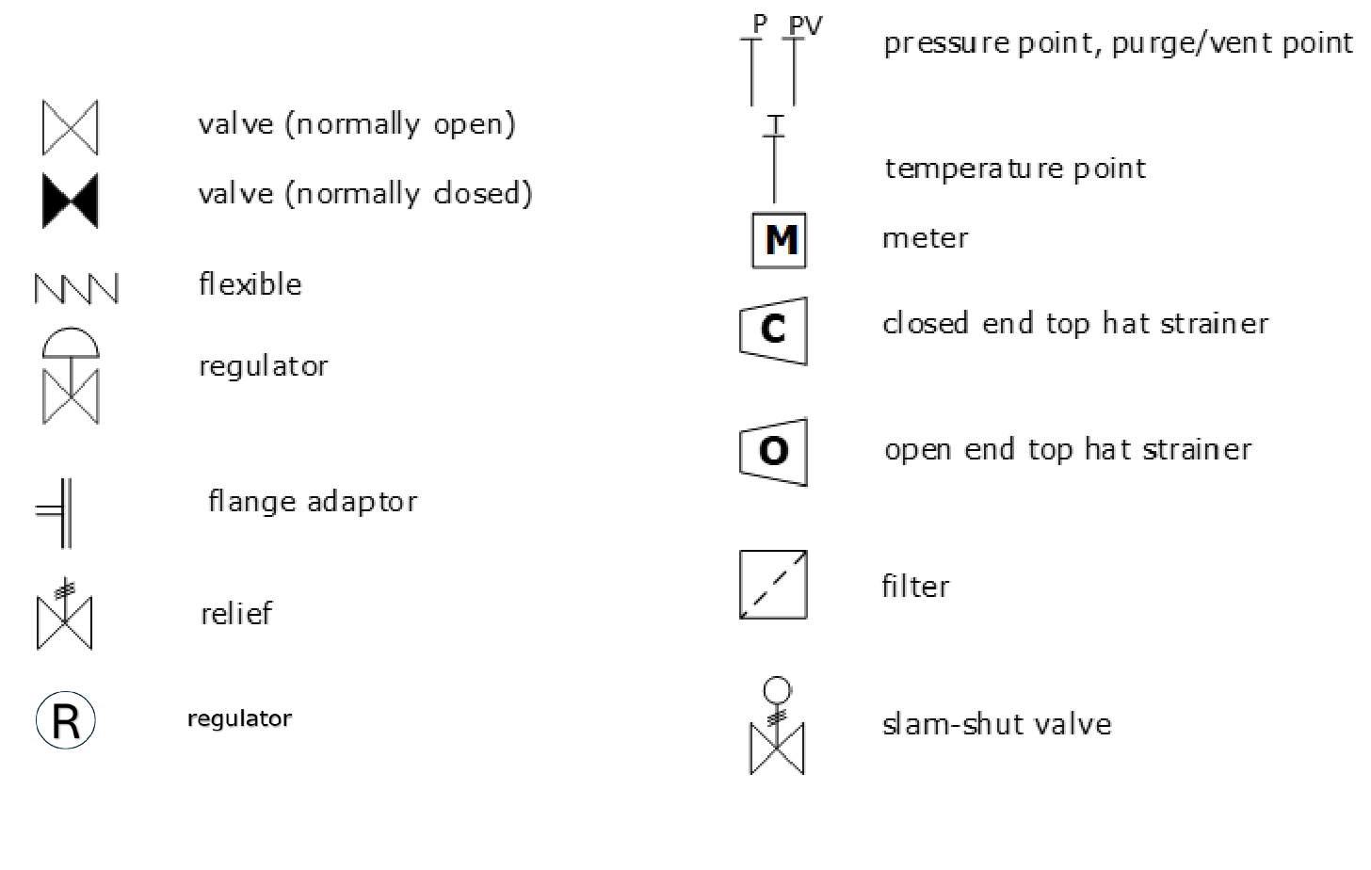
A1.4 UNITS

ft³ hr⁻¹ cubic feet per hour
kg kilogramme
m metre
m³ h⁻¹ cubic metre per hour
mbar millibar
mm millimetre.

A1.5 SUBSCRIPTS

c refers to the consumer’s system downstream of the meter installation. For example, MIP_{c} is the MIP that the consumer’s system may put back onto the meter installation and DmP_{c} is the minimum pressure at which the consumer’s system can operate while maintaining adequate pressure at appliances.

u refers to the upstream Network. For example, MIP_{u} is the MIP that the Network may apply to the meter installation as a result of a fault on the upstream district pressure regulation station.

mi refers to the downstream side of the meter installation, and is a function of the design of the meter installation. For example, MIP_{mi} is the MIP to which the consumer’s system will be subjected by the meter installation i.e. resulting from the operation of a slam-shut valve, and DmP_{mi} is the minimum pressure that the meter installation will provide under extreme conditions i.e. operating with the supply pressure at DmP_{u} and maximum load.
APPENDIX 2 : REFERENCES

This Standard is set out against a background of legislation in force in GB at the time of publication. Similar considerations are likely to apply in other countries and reference to the appropriate national legislation will be necessary. The following list is not exhaustive.

Where British Standards, etc. are quoted, equivalent national or international standards, etc. equally may be appropriate.

Care is to be taken to ensure that the latest editions of the relevant documents are used.

A2.1 LEGISLATION
This sub-appendix lists legislation referred to in this Standard as well as legislation not referenced but which may be applicable.
- Health and Safety at Work etc. Act 1974, as amended
- Gas Act 1986 (as amended by the Gas Act 1995 and incorporating stand-alone provisions of the Utilities Act 2000)
- Dangerous Substances and Explosive Atmospheres Regulations 2002
- Electricity at Work Regulations 1989, as amended
- Gas Safety (Installation and Use) Regulations 1984; 1994, 1998, as amended
- Health and Safety (Safety Signs and Signals) Regulations 1996
- Management of Health and Safety at Work Regulations1992, as amended
- Pressure Equipment (Safety) Regulations 2016.

A2.2 HSE ACoPs
- HSG48 Reducing error and influencing behaviour. Guidance
- L56 Safety in the installation and use of gas systems and appliances. ACoP
- L80 Gas Safety (Management) Regulations 1996 (as amended). Guidance
- L122 Safety of Pressure Systems ACoP
- L138 Dangerous Substances and Explosive Atmospheres Regulations 2002. ACoP and Guidance
- INDG 370 Controlling fire and explosion risks in the workplace. A brief guide to the Dangerous Substances and Explosive
Atmospheres Regulations 2002.

A2.3 OFGEM/SPAA
- CoMCoP Consolidated metering Code of Practice for meter equipment asset managers and meter installers.

A2.4 BRITISH STANDARDS INSTITUTION (abbreviated titles)
- BS 1710 Identification of pipelines and services
- BS 4800 Paint colours for building purposes
- BS 6400-1 Domestic-sized meter installations – low pressure NG
- BS 6400-2 Domestic-sized meter installations – medium pressure NG
- BS 6891 Specification for the installation and maintenance of low pressure gas installation pipework of up to 35 mm (R1¼) on premises
- BS EN 437 Test gases.

A2.5 INSTITUTION OF GAS ENGINEERS AND MANAGERS
- IGEM/G/1 Defining the end of the network, a meter installation and Edition 2 installation pipework
- IGEM/G/4 Definitions for the gas industry
Edition 2
- IGEM/UP/2 Installation pipework on industrial and commercial premises
Edition 3
- IGEM/UP/3 Gas fuelled spark ignition and dual fuel engines
Edition 3
- IGEM/UP/6 Application of positive displacement compressors to
Edition 3 Natural Gas fuel systems
- IGEM/GM/6 Non-domestic meter installations. Standard Designs
Edition 3
- IGEM/GM/8 Meter installations. Flow rate exceeding
Part 1 Ed 3 6 m³ h⁻¹ and inlet pressure not exceeding 38 bar. Design
- IGEM/GM/8 Meter installations. Flow rate exceeding
Part 2 Ed 3 6 m³ h⁻¹ and inlet pressure not exceeding 38 bar. Locations, housings and compounds
- IGEM/GM/8 Meter installations. Flow rate exceeding
Part 3 Ed 3 6 m³ h⁻¹ and inlet pressure not exceeding 38 bar. Fabrication, installation, testing and commissioning
- IGEM/GM/8 Meter installations. Flow rate exceeding
Part 4 Ed 3 6 m³ h⁻¹ and inlet pressure not exceeding 38 bar. Operation and Maintenance.

Housing roof area/height of lift

BLANK PAGE

